TMGP audience survey analysis

# Introduction:

We conducted this survey to evaluate on our current content and services (a), and help us understand how we can do better to be of service and produce content that interests you (b), as well as how The Middleground Productions can reach out to more people in our community (c).

This is in align with our market research towards cultivating and building our new brand identity, as well as evaluate our current audience’s perspective with viewing our shows and online content, and whether it is in line with the company’s current goals and objectives. We would like to explore different changes in the proposed recommendations at the end of each part, which would be collated in the end.

# Participants demographics:

**Total respondents: 16**

## Age group:

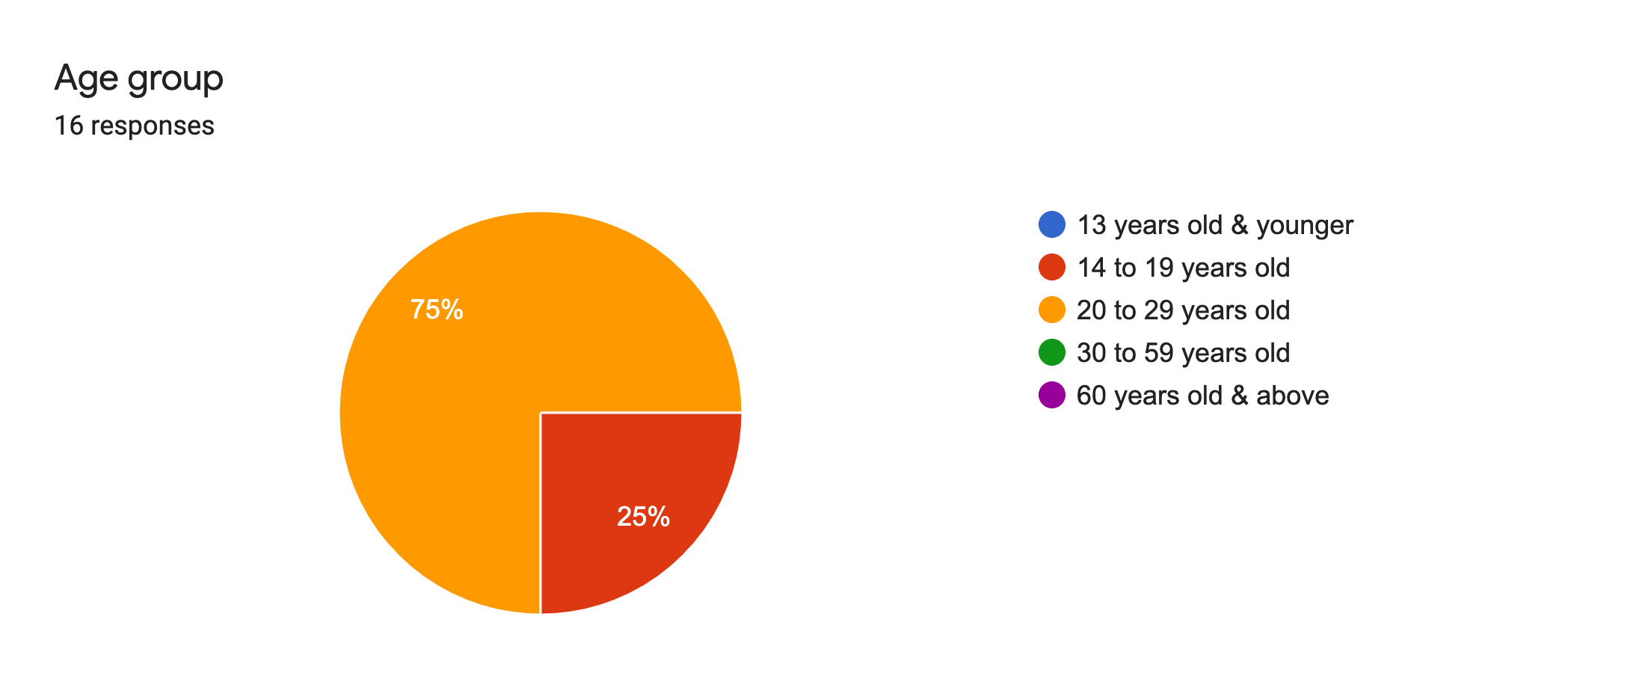

75% 20 to 29 years old

25% 14 to 19 years old

Notes: The respondents’ age group is in line with our target audience’s age range.

## Race:

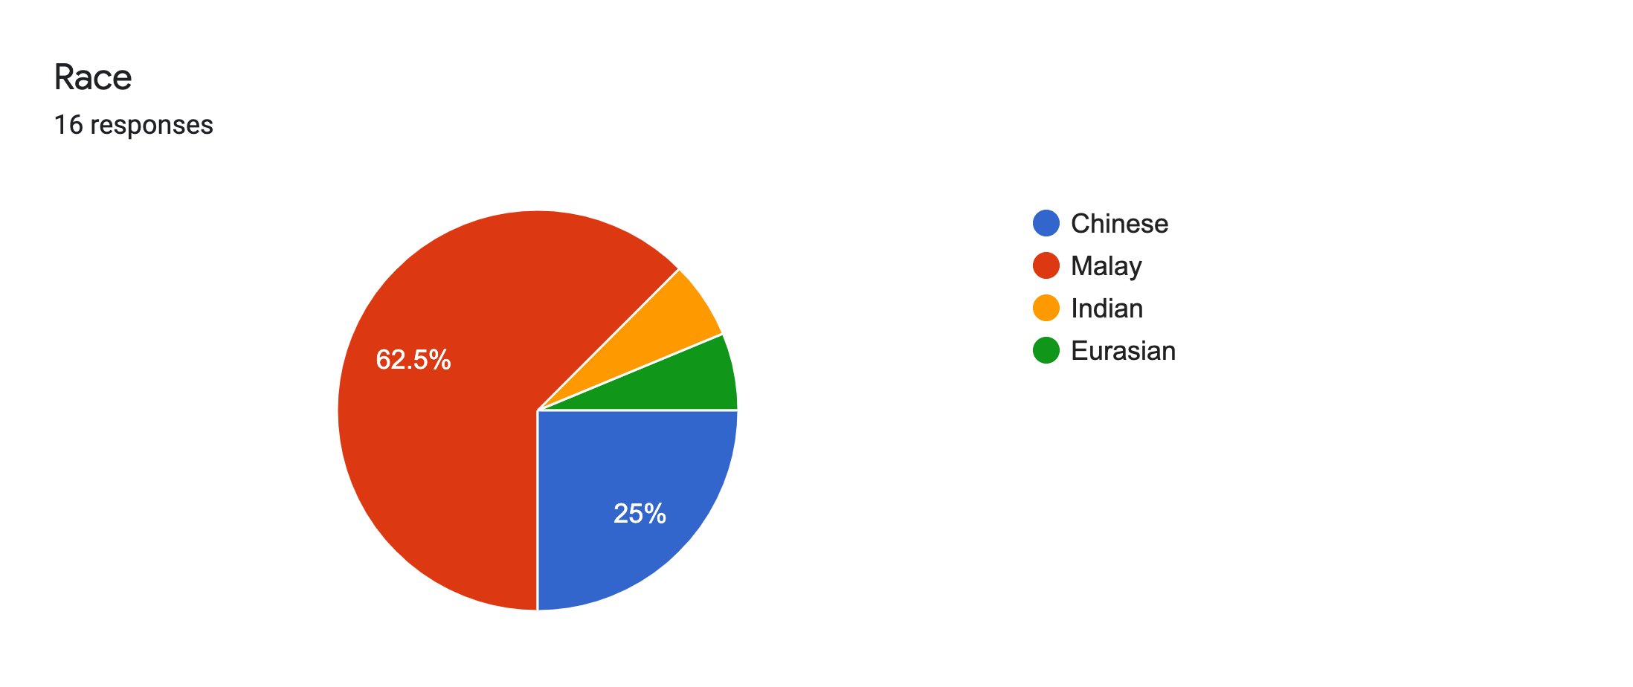

62.5% Malay

25% Chinese

6.3% Indian

6.3% Eurasian

Notes: We have accomplished to garner responses from all four main ethnicities in Singapore. Our respondents are mostly Malay, hence we can deduce that most of our audience are Malay due to our Malay-community focused themed productions, which are After 7 and Kampong Pokok.

Recommendations: We can aim to create more shows that attract more general audiences. Hence, we can propose to aim to diversify our audience demographics. For example, in the next production, we hope to attract more Chinese, Indian or Eurasian audiences. This is to acquire that we are spreading more to different communities in Singapore and more groups of youths can be reached, based on race.

## Profession/Occupation:

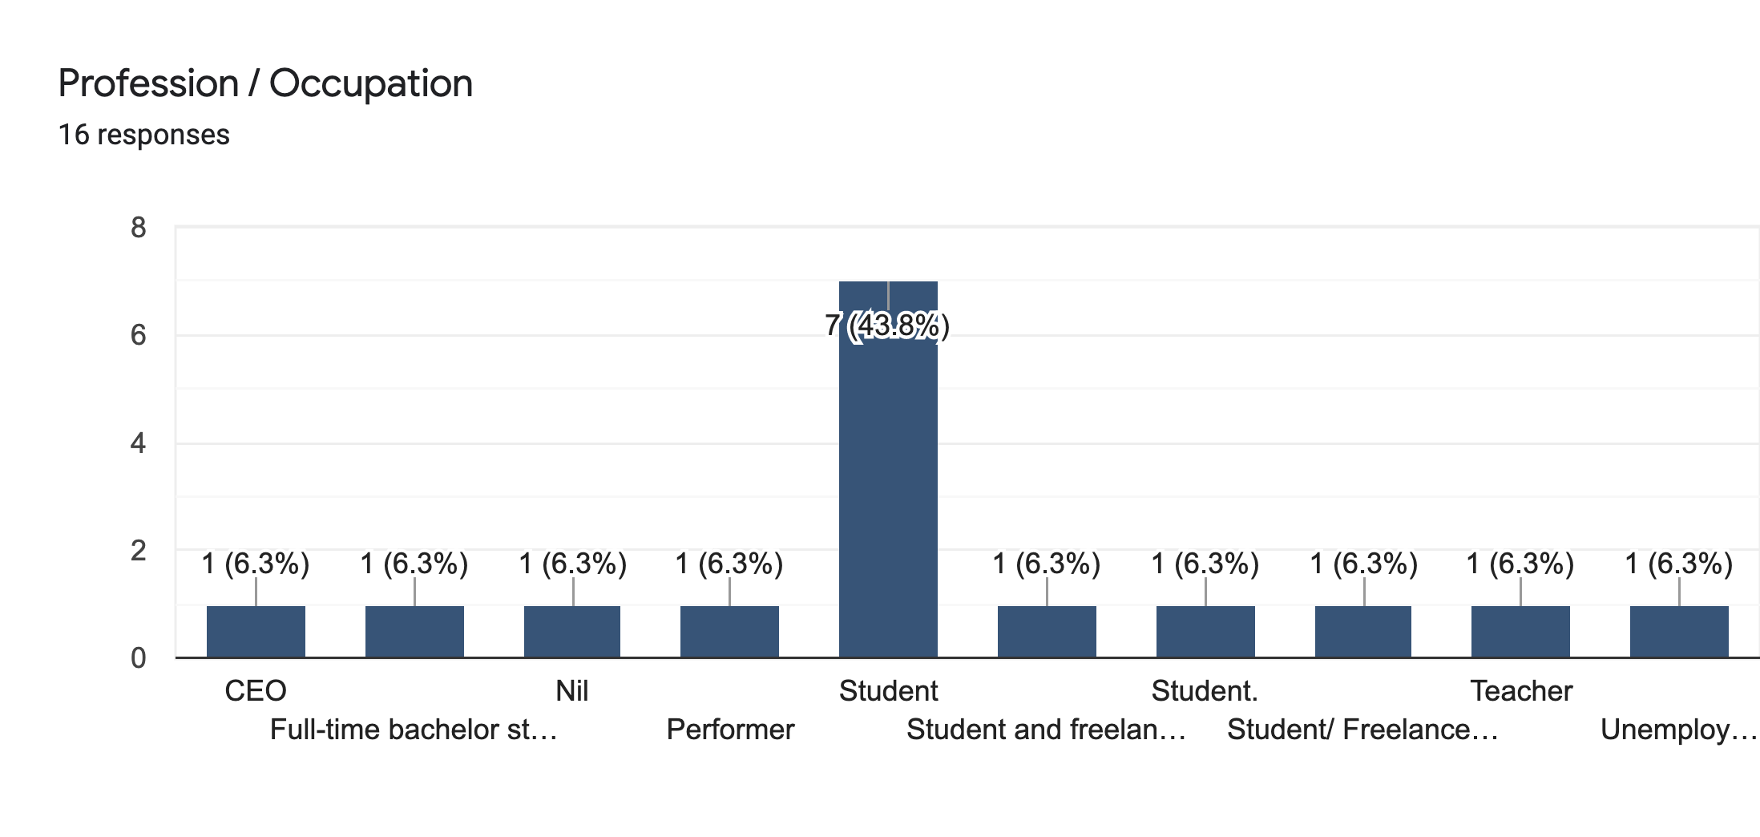

Students (Non-Working): 9

Students (Working): 2

Working adults: 3

Unemployed: 2

Notes: Most of our respondents are students, hence we can conclude that we have a large demographic of students in our audience. This reflects well on our student price marketing campaign, attracting more audience from that age group/occupation.

Recommendations: We can think about how we can reach out and appeal to the adults in the labour force (unemployed + employed) more to our shows.

We can look at the price of our tickets and our marketing plans towards targeting that occupation group

Main question: How can we promote more to the working class?

It can also be a review of our company image to them, as well as the quality of which we present our performances. For example, are our performance of high calibre quality or of low quality? We can rethink about the talent we bring in and training and development of them, the professionalism of the whole team, as well as how we can rectify the process of our productions so that it can increase the quality of our performances. For example, do we need more planning time? More roles delegation? More rehearsals time? More cross-training or exposure to different training and development activities conducted by external instructors? More research on the theme of the play?

## How did they found out about the survey:

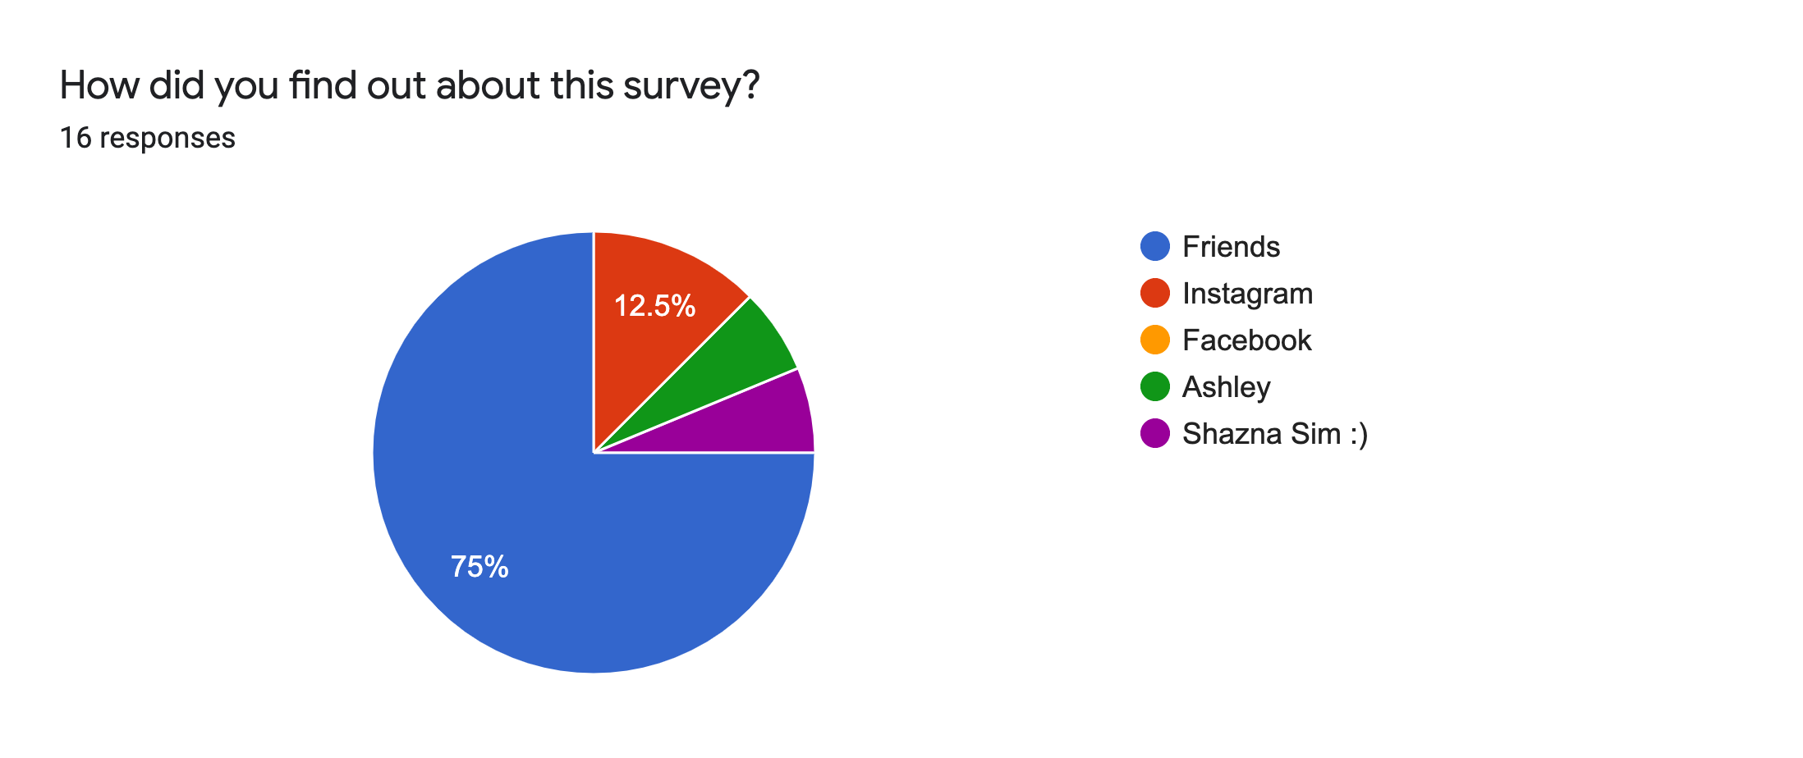

* 2 respondents are reached out via Instagram
* 0 respondents from the mass email sent out
  + Sent out late
* 14 respondents reached out via word-of-mouth

Notes:

We need to relook at our Instagram marketing strategies and how can engage and interact with more audiences using the profile (through ig stories/posts). This can be using the function buttons more or try different programmes that increases audience engagement.

Word-of-mouth is a strong outreach about news about our content for now. We can deduce that we have a strong community and networking of people/audience around our company. This is including our TMGP Tribe.

# Past Productions:

Survey mistake: The answers for all questions is not production-specified. Instead, the respondents gave their thoughts based on the shows they have watched in a general perspective. For example, one person watches 3 productions and uses the combined experiences to give a general answer in our survey.

Example:

|  |  |  |  |  |  |  |  |
| --- | --- | --- | --- | --- | --- | --- | --- |
| (ME)ntal, Kampong Pokok, After 7, Half An Apple | 4 | 4 | 4 | 4 | Yes | Each production have different values at the end. However, one value that I took from all was to never take things for granted. | Better publicity and better storytelling. |

This affects our data when looking into customer experience in individual productions.

## (ME)ntal:

Number of respondents that were audience members: 4

Entertainment (1 Not entertaining / 5 Very entertaining):

Notes: Our audience generally found (ME)ntal entertaining but the entertainment impact is not great.

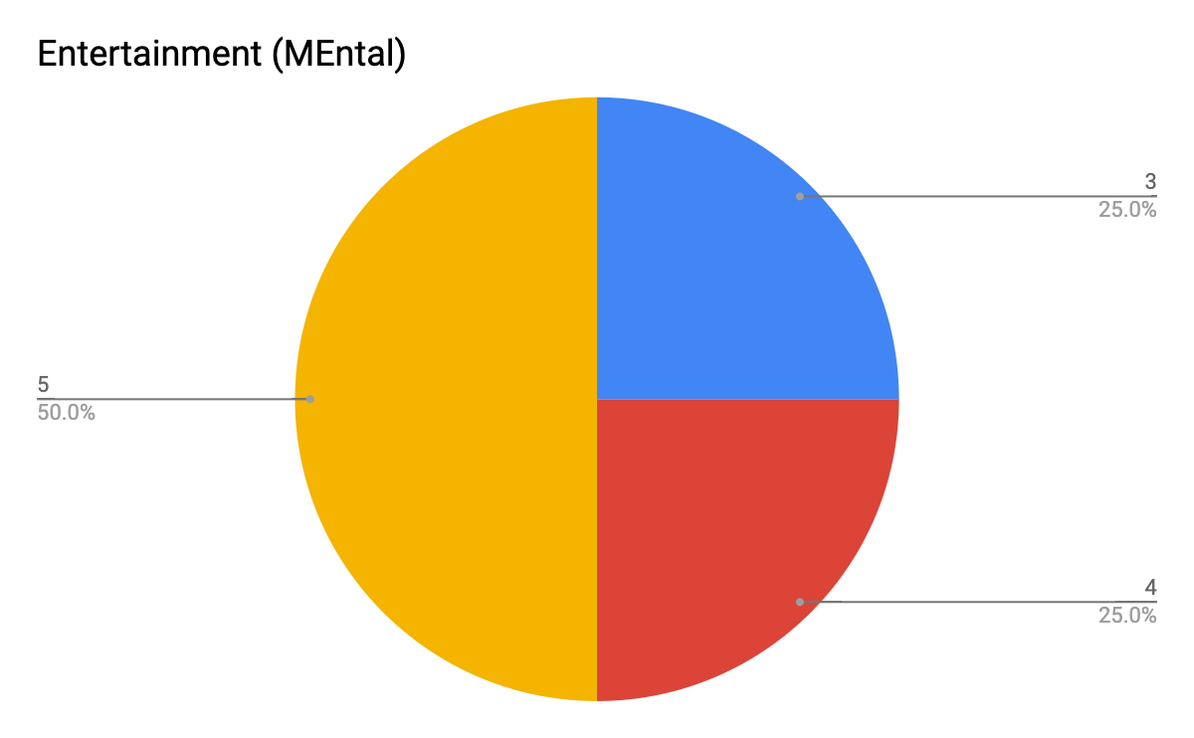

Educational (1 learnt nothing/ 5 learnt a lot):

Notes: Our audience generally found (ME)ntal educational and informative.

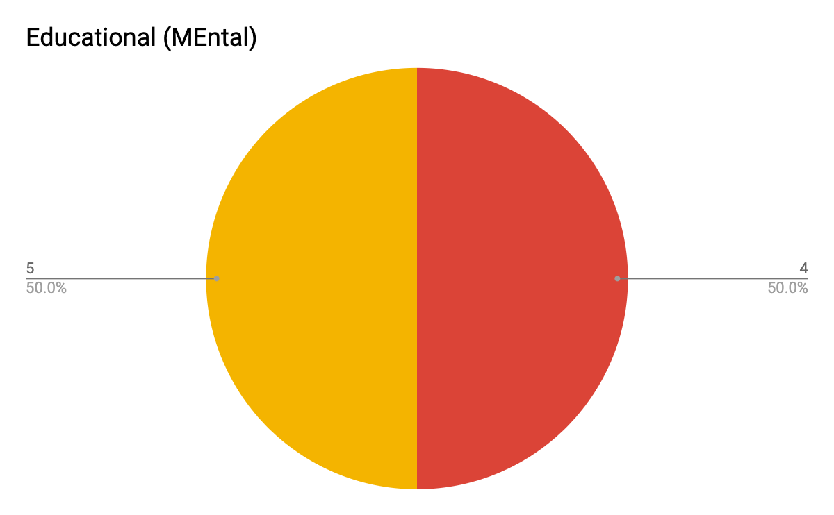

Immersion (1 Not immersive/ 5 very immersive):

Notes: Our audience generally felt immersed in their experience in (ME)ntal but it is not very impactful and memorable.

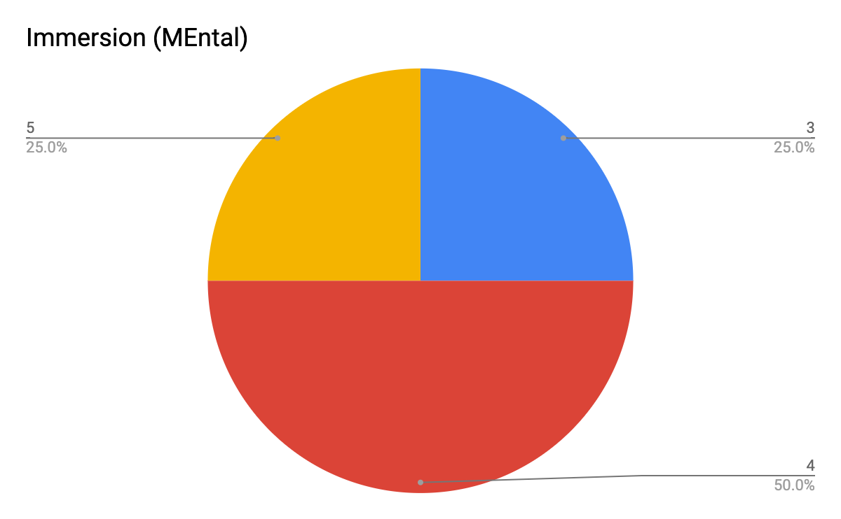

Audience satisfaction (1 strongly disappointed/ 5 strongly satisfied):

Notes: Our audience is generally satisfied with the content and performance displayed in (ME)ntal.

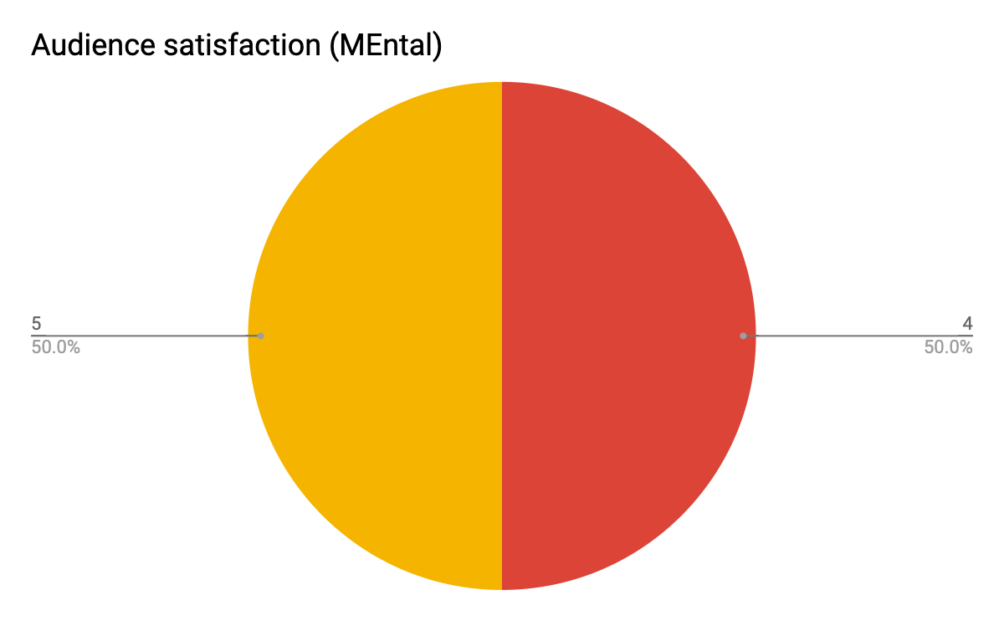

Do you think our price range was reasonable and was in line with your expectations of the show? (Yes/No):

Yes - 4

No - 0

Notes: There is a 100% satisfaction with pricing

Evaluation: (ME)ntal has a positive reaction in terms of being educational and its audience satisfaction. However, it can be improved on immersion and entertainment. To improve immersion, we can relook at our front-of-house arrangements and set-up, as well as our storytelling approach. To improve on entertainment, we can focus on the training and development of our artists, our storytelling approach and our overall quality of performance we present to the audience.

## Kampung Pokok:

Number of respondents that were audience members: 5

Entertainment (1 Not entertaining / 5 Very entertaining):

Notes: Our audience was pleasantly very entertained with Kampung Pokok.

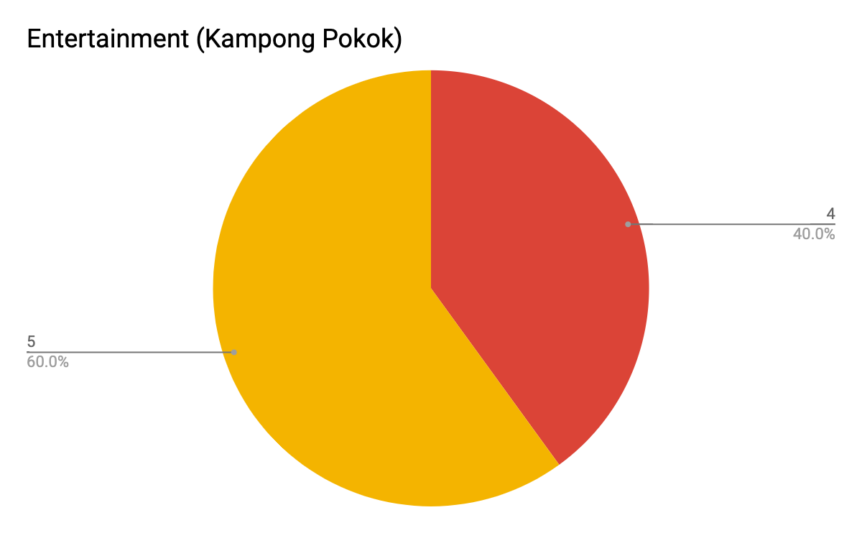

Educational (1 learnt nothing/ 5 learnt a lot):

Notes: Our audience found Kampong Pokok educational based on the morale of the story.

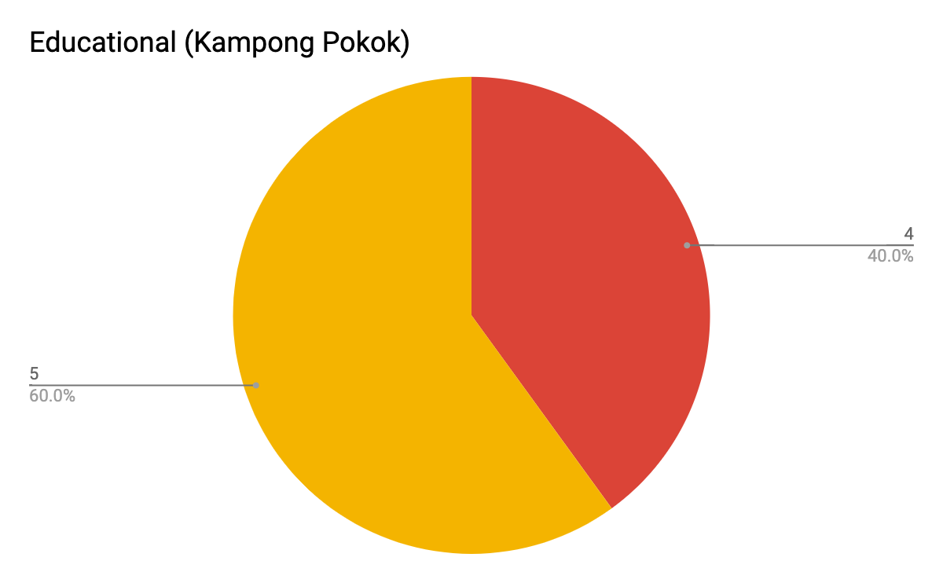

Immersion (1 Not immersive/ 5 very immersive):

Notes: Our audience was felt very immersed during their experience watching Kampung Pokok.

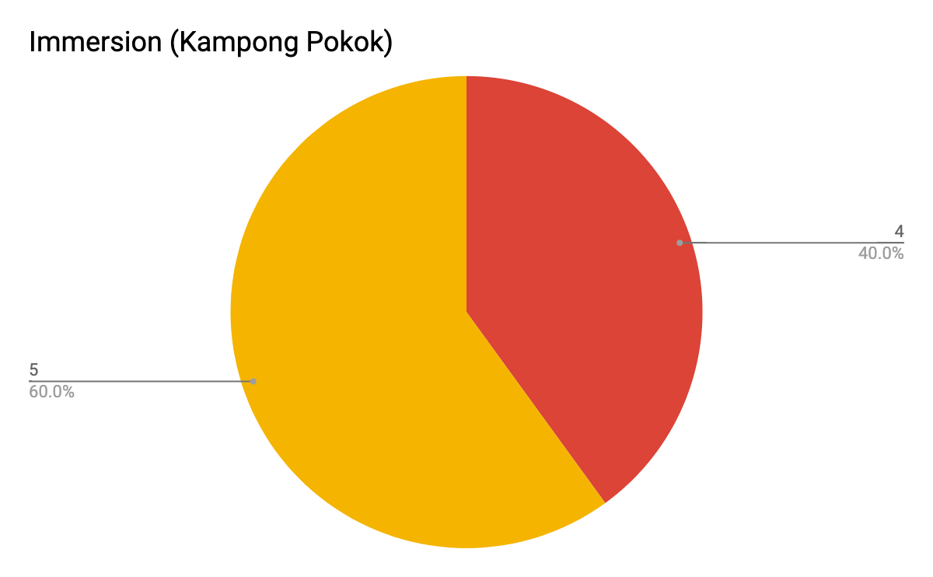

Audience satisfaction (1 strongly disappointed/ 5 strongly satisfied):

Notes: Our audience is generally satisfied with the content and performance displayed in Kampung Pokok.

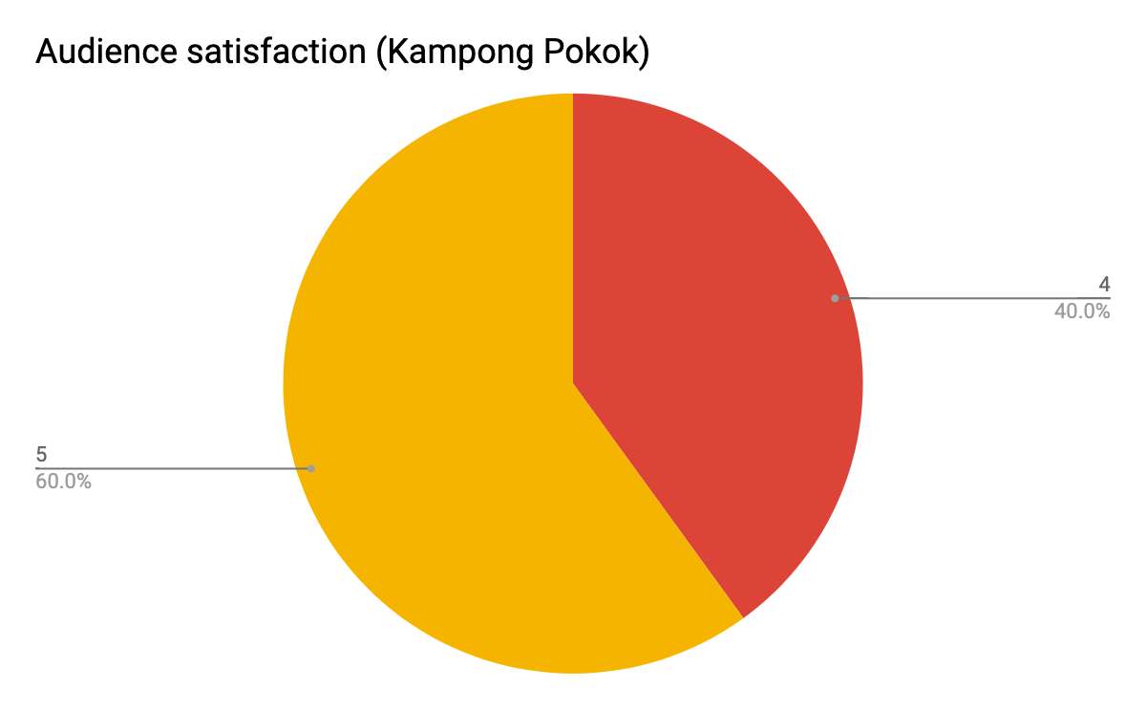

Do you think our price range was reasonable and was in line with your expectations of the show? (Yes/No):

Yes - 5

No - 0

Notes: There is 100% satisfaction with pricing

Experience:

1. Kampong pokok was funny hehe. Hiii 😘

Evaluation: Kampong Pokok has achieved its objectives of being a comedy as the audience was greatly immersed and entertained during the show. We can consider exploring creating more plays in the comedic genre and incorporating more comedic elements into our plays. We can research more on comedic plays and how we can create our own plays according to it. This can attract more audience within our target audience.

## After 7:

Number of respondents that were audience members: 10

Entertainment (1 Not entertaining / 5 Very entertaining):

Notes: Our audience was generally entertained with After 7, but its entertainment impact is not memorable.

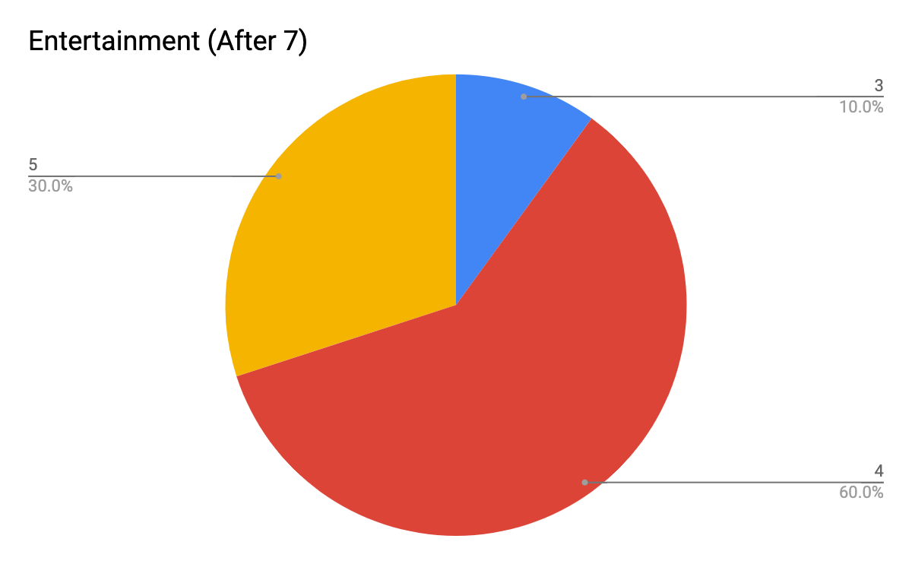

Educational (1 learnt nothing/ 5 learnt a lot):

Notes: Our audience found After 7 quite educational based on the morale of the story.

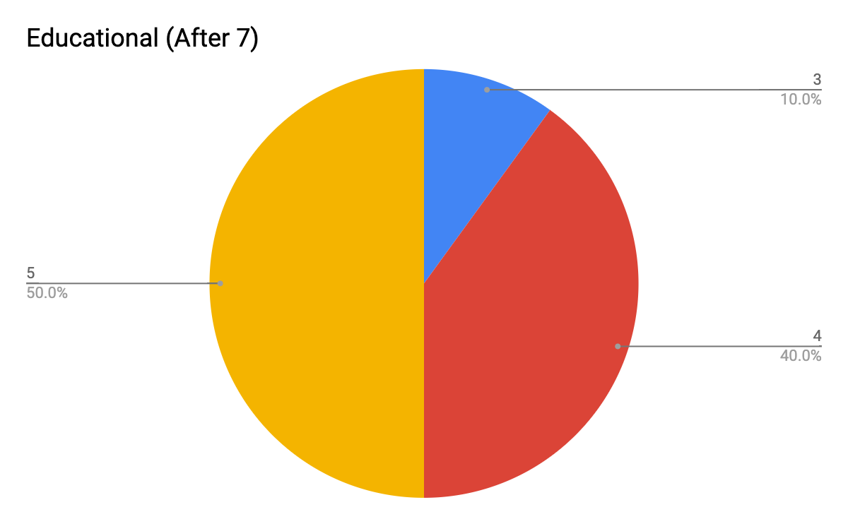

Immersion (1 Not immersive/ 5 very immersive):

Notes: Our audience was felt generally quite immersed during their experience watching After 7.

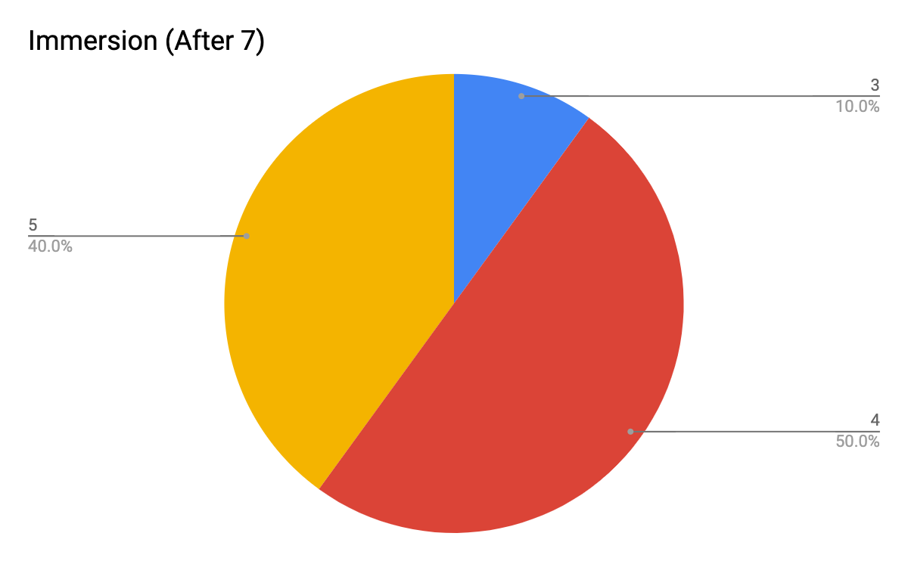

Audience satisfaction (1 strongly disappointed/ 5 strongly satisfied):

Notes: Our audience is generally satisfied with the content and performance displayed in After 7.

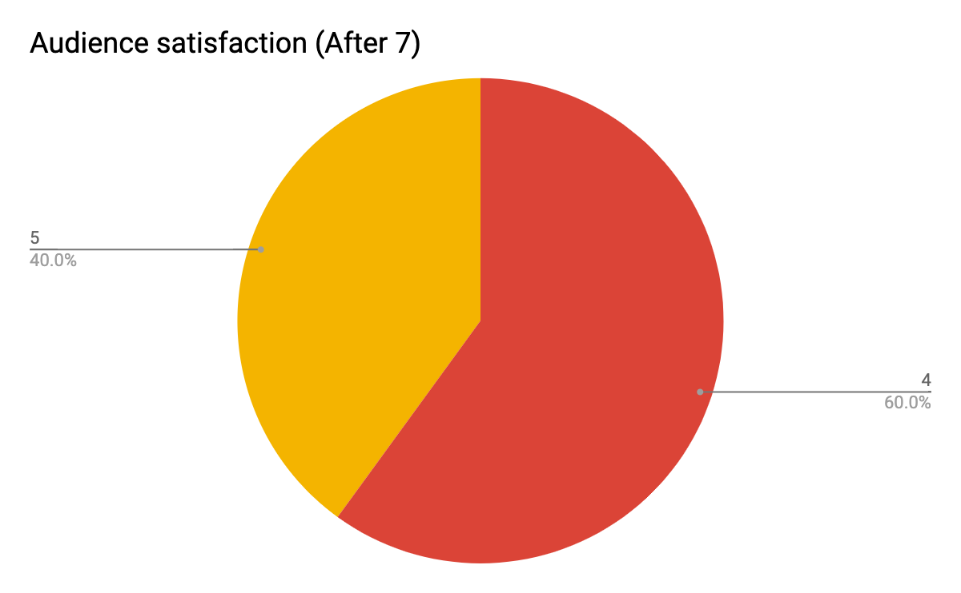

Do you think our price range was reasonable and was in line with your expectations of the show? (Yes/No):

Yes - 10

No - 0

Notes: 100% satisfaction with pricing

Experience:

1. I feel that After 7 shared about personal reflection and that family mattered. Sometimes you just have to take a short break and look around at yourself and surroundings. Appreciate what you have going for you and the people around you. Acknowledge the mistakes made and improve from there. Because we are only human, no one is perfect and that's ok.
2. After 7 gave me an insight of an individual who went astray and yet, came back to the right path with Allah's mercy. A reminder to never judge a person for how they appear to be. A clear cut message which left a strong imprint till date.
3. Watching After 7 was an emotional rollercoaster for me..

Feedback:

1. I think.. Better publicity.. Although some of the shows were sold out , I think that you guys can get an even larger audience for your shows..
2. I have only sat down for one show, After 7, while I participated in the others. As for After 7, storyline was impactful yet I've seen a similar piece over and over again be it on television or social media. With the same overarching theme, I hope to watch an alternative storyline next time! I also believe that these shows could gain more audience with better publicity and connections :)

Evaluation:

The audience found After 7 an emotional experience and found that aspect the most memorable. We consider relooking into more similar themes and bring it out in our plays. One major feedback is the publicity of our shows, which tells us to look back at our marketing plans for our future productions. In addition, we can look at different perspectives and stories of the same theme, by connecting with more people to share their experiences and stage it up as one of our future productions. However, some audience had a hard time immersing and being entertained with the play. This may be due to the fact that After 7 is centred around the Malay community and Islam. Audiences outside that circle may have felt disconnected with the content and intentions of the storyline, although they may learn more about the Malay culture and the religious practices of Islam. Community-centred plays are important in engaging the different communities in Singapore with one another. This helps to promote the growth of the identity of the central community by allowing the members in that community to come together and being immersed in their own cultural experience. We can look into more certain plays like this in future, but we can incorporate an educational factor so that audiences from other communities in Singapore can feel as entertained, educated and engaged.

## Half an Apple:

Number of respondents that were audience members: 8

Entertainment (1 Not entertaining / 5 Very entertaining):

Notes: Our audience was quite entertained with Half an Apple. Some people felt entertained, while others did not. This highlights that our show’s content and performance was not engaging and sustained the audience’s attention.

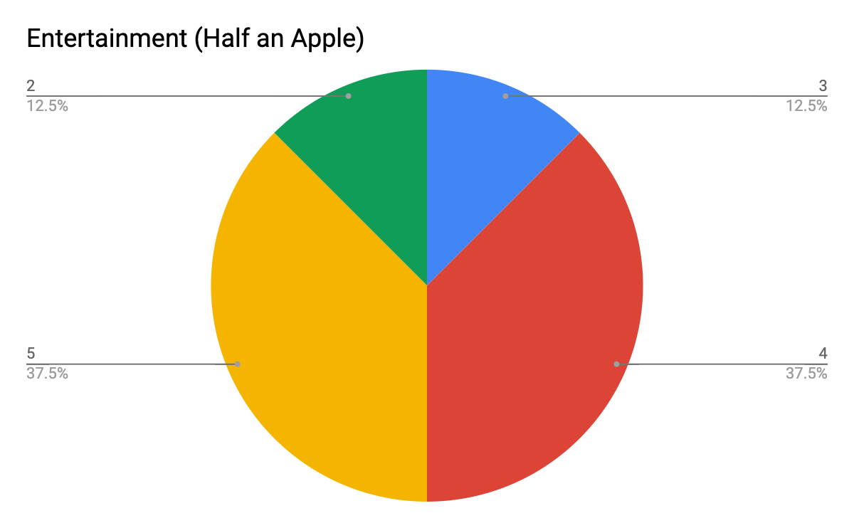

Educational (1 learnt nothing/ 5 learnt a lot):

Notes: Our audience found Half an Apple quite educational as Half an Apple was a production educating the public about mental health. Hence, we can see that Half an Apple did achieve its objectives of being an informative show spreading awareness about mental health. However, we will need to relook on how we can make it more educational, so that it’s educational content can be received better, or we can promote the awareness and information more of mental health through the front-of-house or the clarity of the storyline.

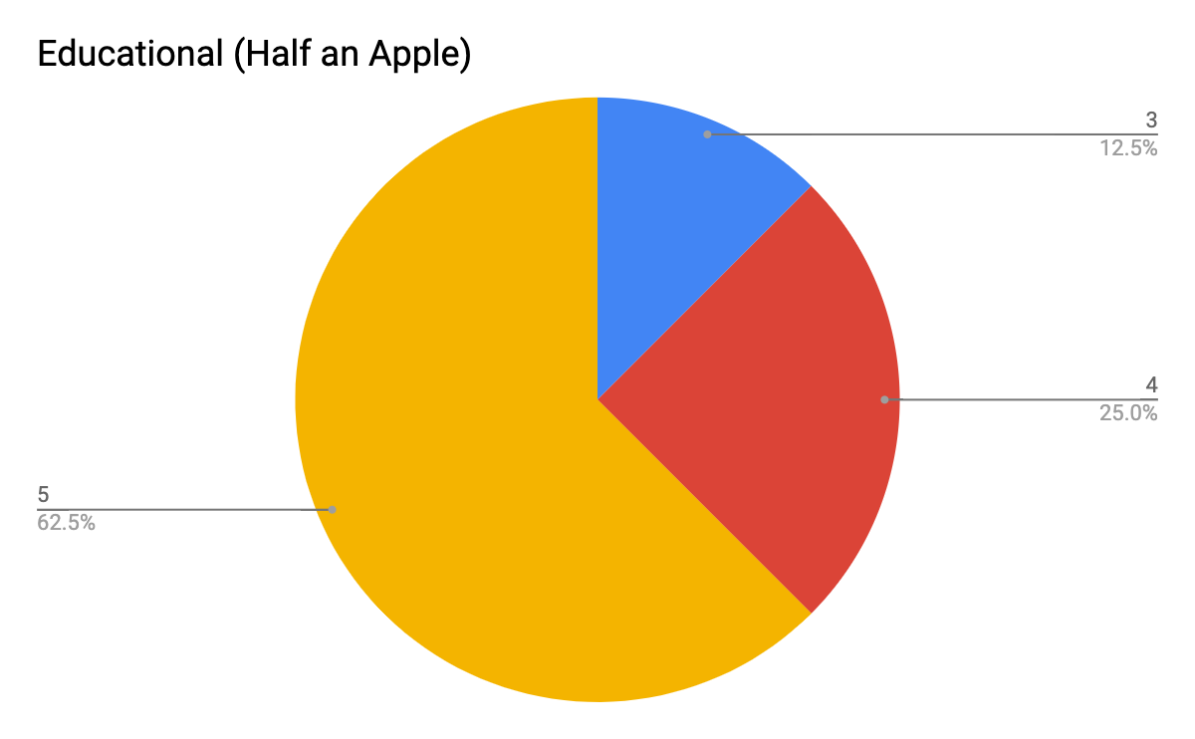

Immersion (1 Not immersive/ 5 very immersive):

Notes: Our audience was felt quite immersed during their experience watching Half An Apple. We can see the mixed reaction regarding the open TV live audience format of the performance. This shows that different people take in differently about experimental storytelling methods.

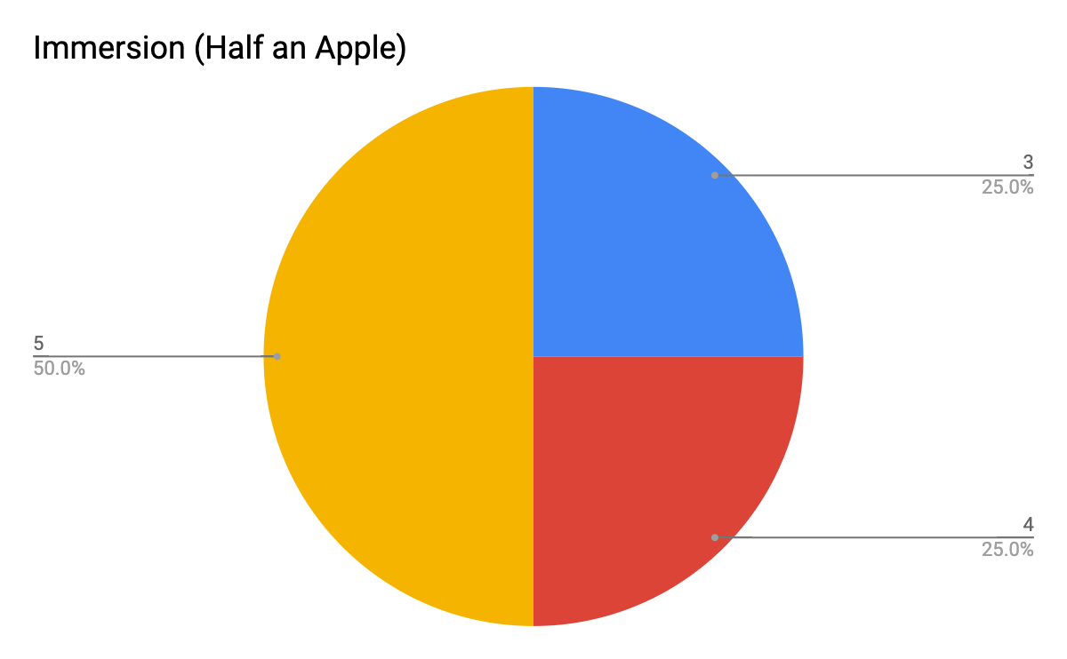

Audience satisfaction (1 strongly disappointed/ 5 strongly satisfied):

Notes: Our audience is generally satisfied with the content and performance displayed in Half an Apple.

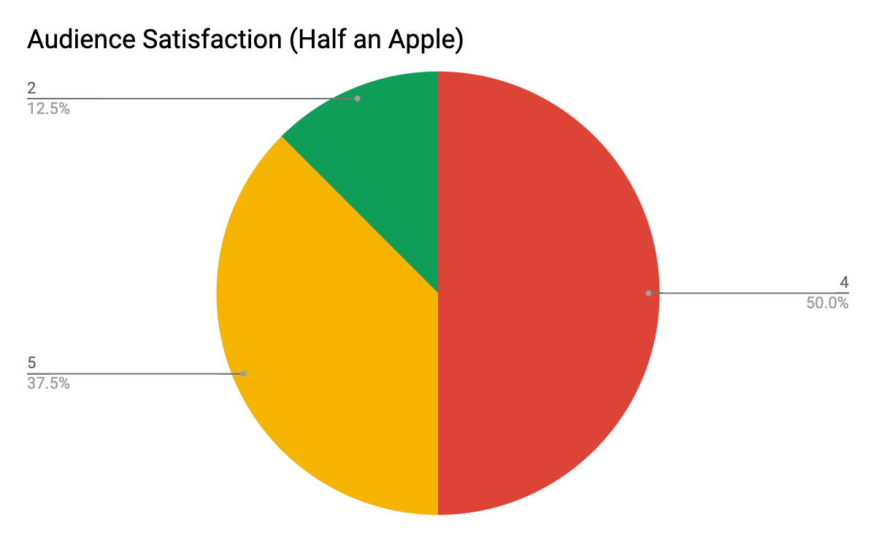

Do you think our price range was reasonable and was in line with your expectations of the show? (Yes/No):

Yes - 8

No - 0

Notes: 100% satisfaction with pricing

Experience:

1. Half an apple wasn’t as impactful as after 7. The storyline was somehow there however, the message behind the whole play wasn’t clearly delivered to the audience. Some parts of the play were overly done to which affected the audience experience.
2. It was clearly an emotional piece that showed how much heart the actors and production team had. However, the actual issue brought out was superficial and could have dug in deeper through more intensive research and understanding different point of views.

Evaluation: Half an Apple received mixed reactions. However, one of the significances of the play is the educational portion which was one of the main objectives of the production. Although it was successful, it could have been done better by researching more in-depth and understanding different point-of-views of people suffering from such illnesses and stage it. The audience found the content and storytelling more surface level and was hard to immerse in. We have to relook in how we experiment with different storytelling approaches, whether it can engage and entertain audiences in our age range. We need to prioritise the information and context we bring to the table and how we present it to the public in our later works.

## 

## General

Experience:

1. There are certain parts that have reminded me of myself. They helped me reflect on my own experiences and also brought me into their journey of tackling the problem - which could be one of the many possible ways.
2. Each production have different values at the end. However, one value that I took from all was to never take things for granted.
3. the shows produced are relatable and are issues that almost everyone in today’s society is facing.
4. Exciting to watch friends up on stage

Feedback:

1. Better publicity of the shows
2. Better publicity and better storytelling.
3. Storylines would have been better if told in a relatable experience or given from a whole different point of view from the usual mindset that we have to matters.
4. I believe less is more. Rather than attempt 4-5 shows a year, perhaps TMGP could aim to do a solid and intensive 1-2 shows a year (either new work or based on an existing playwright's work). That way, more groundwork could be laid in its acting, directing and storytelling. At the end of the day, the story and characters have to be the gravitational pull that brings people in to watch and not because of ticket prices or friends. Thus, TMGP definitely has potential if the company also invest the time and money in training the actors for the respective roles.

Evaluation: We need to relook at our marketing strategies and plans when promoting our productions to different groups of people in our target audience range. We can develop our stories more in the future in line with our company goals (entertain, educate and immerse) and that the story and how we present it can be received clearly and efficiently to our audience in line with our play’s objectives and themes.

# Future interest:

## Interest in future productions:

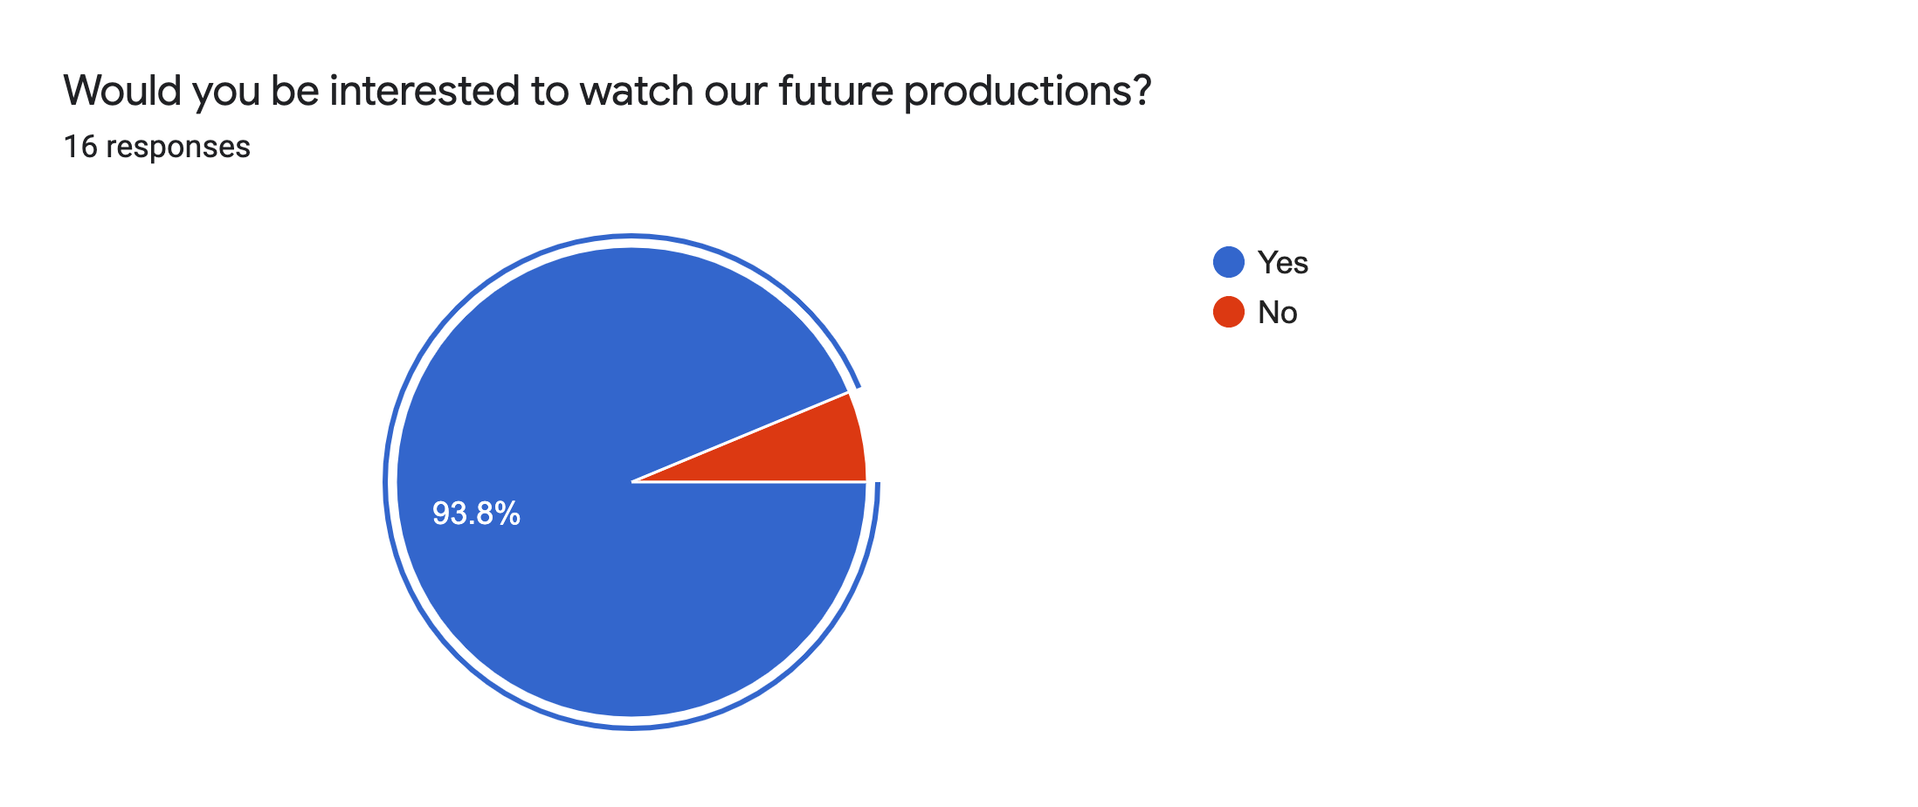

Yes - 15

* i want to see more theatre performances
* I'm interested in TMGP's growth. Been there since the start and I see the potential. It's a tough industry and there are many competitors. Slowly but surely, TMGP can succeed.
* Excited to see new ideas being brought to the table.
* I wanna see what tmgp hv more to offer.. im saying this as an audience :))
* Entertaining
* Support local talent and friends
* Curious to see what will be put up.
* To watch the growth of every performer growing through each play to be better and better in future.
* From an audience point of view, I feel that the shows are somewhat what I can relate to as a teenager. I enjoy the performance and the talents in TMGP are great performers.
* I enjoyed half an Apple immensely because of the topics and themes explored. Don’t see much of it in local theatre.
* Like theatre
* Storylines are very interesting and relatable
* I would like to see how big TMGP can grow and i'm sure it will grow.

No - 1

* At this current moment, I feel the team is not ready to stage a show. Instead, they need to focus on basic training. What can work, are showcases of work-in-progress.

Evaluation: We have a lot of people supporting our growth. However, we need to build an HR strategy in our business development plan, so that we can train and develop our talent and team members.

## Themes in the future:

Real world problems, religion, culture, social issues, youth, personal problems

* Real-World Problems
  + Terrorism
  + Covid-19
* Social Issues/Social stigmas
  + Racial Discrimination
  + Inequality - racial, workplace, gender, etc.
  + LGBTQ+ community
  + Mental health
  + Family violence
  + Single parents
* Culture and religion
  + Traditions
  + Minority ethnic groups
  + Extracting a hadith from the Quran and putting it into play.
  + Being Asian
* Personal issues
  + Money matters
  + Family
  + School life
  + Struggles in youth
  + Struggles of a graduate student - finding a job/maintaining a job/or shift in interests.
  + Being stuck at a crossroad - there is always a point in life where we will face this and I always wonder, how much of this do I need to sacrifice to achieve that? Or should I sacrifice that to maintain this?
  + Stress on the current generation

# Instagram content:

Mistakes: There are some people put the same option twice ( 2 1s and 2 4s), affecting the data.

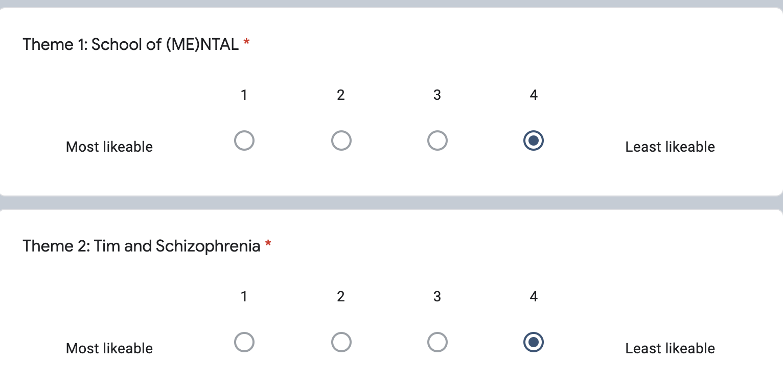

## Rank the 4 themes according to your preference (1 being the most likeable, 4 being the least likeable)

Theme 1: School of (ME)ntal

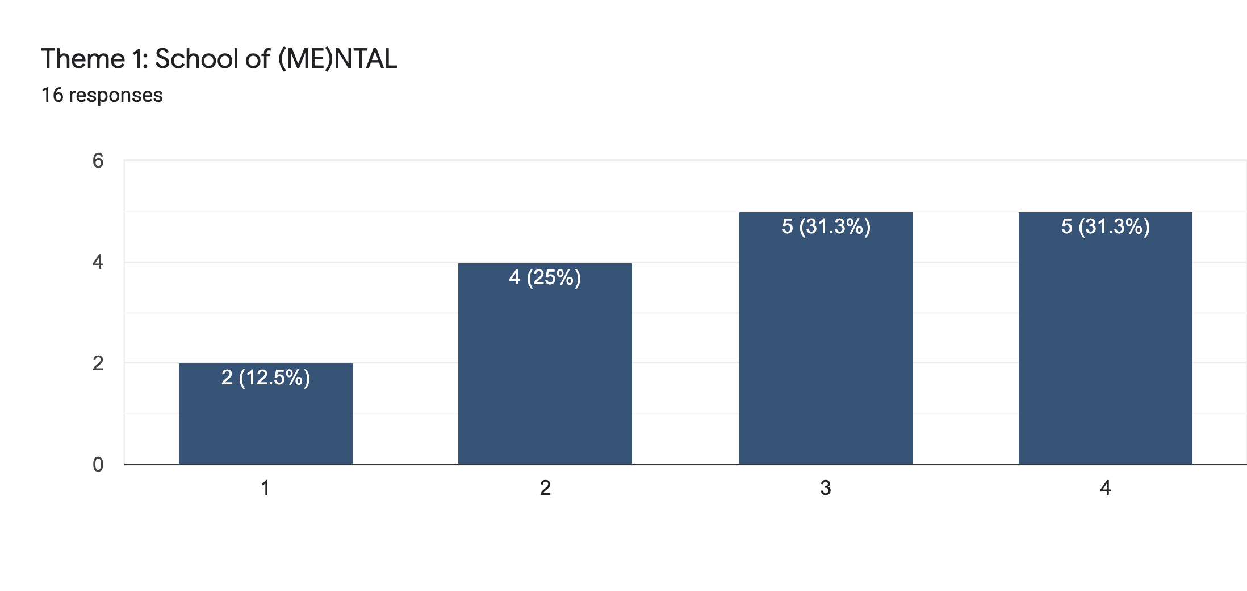

Top choice:

* It's unique
* Text is content heavy and informative.

Bottom choice:

* Too wordy
* The message for this is good but the design is kinda hard to read. The color is not as pop-ish as my first choice so it kinda looks dull. Also the font is a lil bit hard to read.. Especially with that color scheme and having the picture of the girl in the background of the second picture.. Although the text is white , it’s hard to read because the picture of the girl and the text kinda clashes.. It also looks like something the Health Promotion Board would put out for certain campaigns.
* Too many words
* Too childish boring
* The font for both is hard to read. There are too many words as well. Maybe the information could be divided into different slides with minimal words. The colour schemes do not really work too because they don't have much contrast. I guess like green and grey work well but overall, i think there can be a better approach. Like the background could be white instead to bring out the visuals better. Also there is a typo in the slide 1 - "chld".

Evaluation: The audience found School of (ME)ntal too wordy, boring and childish. Some had a hard time reading and receiving the content, that does not achieve our educational and immersive portion of our objectives of the post. This is due to the flaw in design, colour palette and readability of the post.

Theme 2: Tim and Schizophrenia

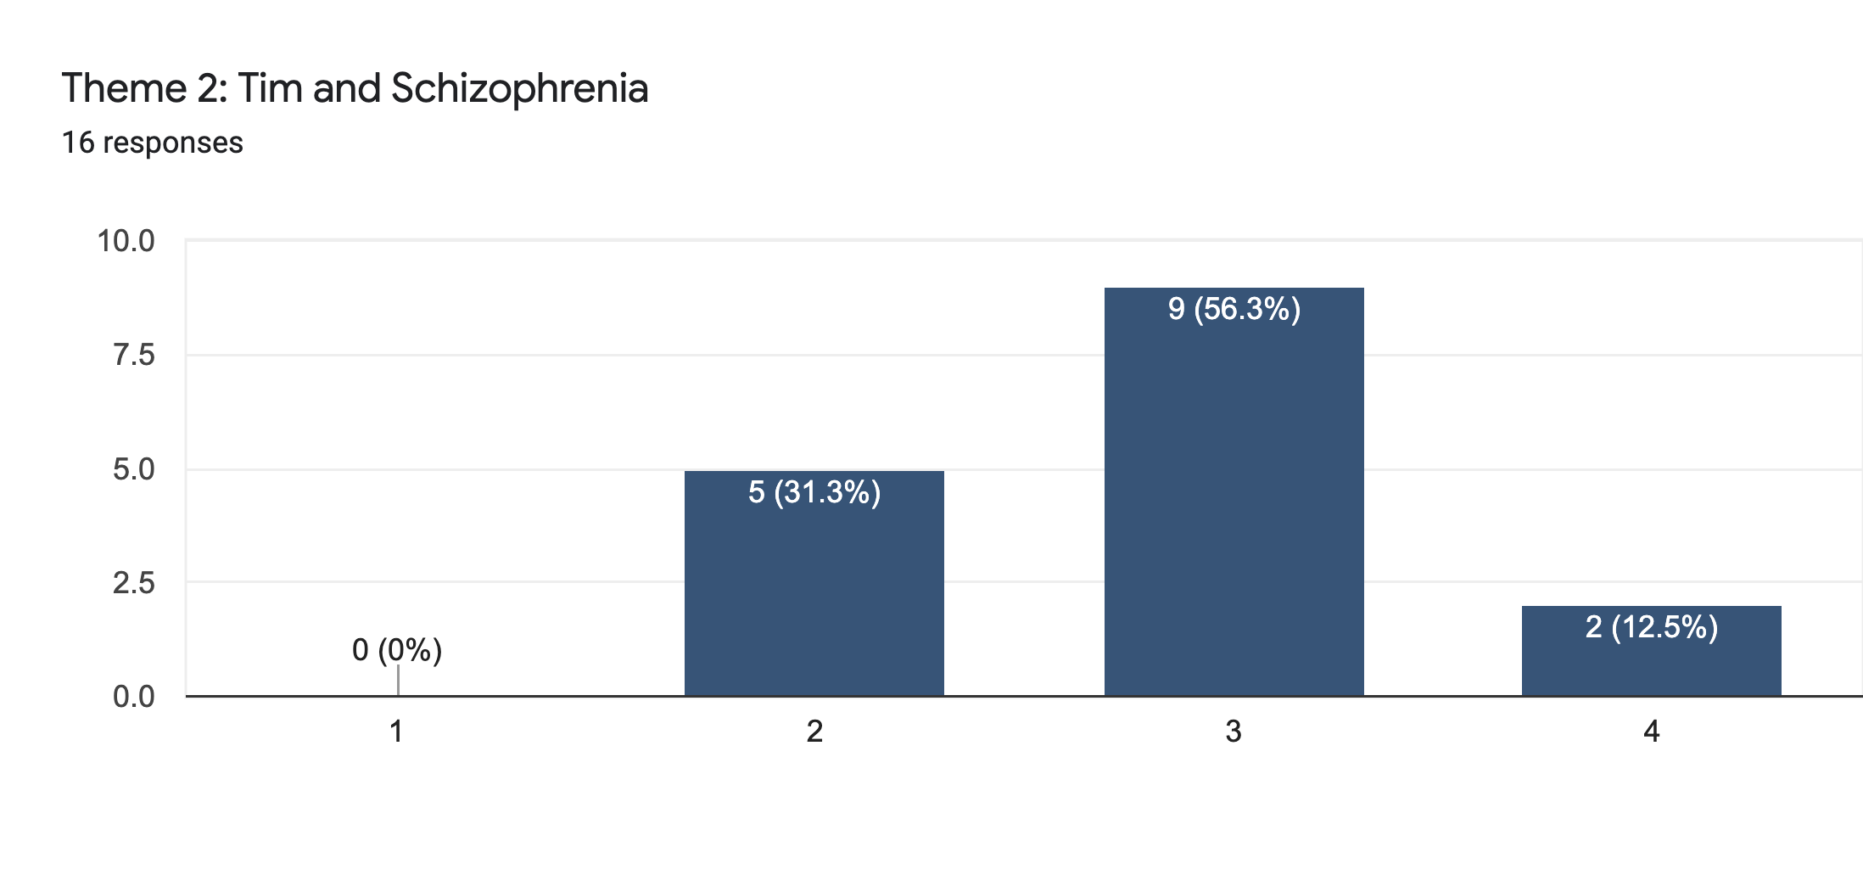

Top choice:

Bottom choice:

* Not very interested in it
* The font for both is hard to read. There are too many words as well. Maybe the information could be divided into different slides with minimal words. The colour schemes do not really work too because they don't have much contrast. I guess like green and grey work well but overall, i think there can be a better approach. Like the background could be white instead to bring out the visuals better. Also there is a typo in the slide 1 - "chld".

Evalutaion: Not many audiences favoured or was interested in this theme because they found the readability of the post is ineffective and design does not capture their attention. There should be more detail paid into the output of the content, and make sure there are no flaws in the post, such as spelling errors. Hence, we can conclude that design and readability are important to capture an audience’s attention.

Theme 3: Walking on Thin Ice

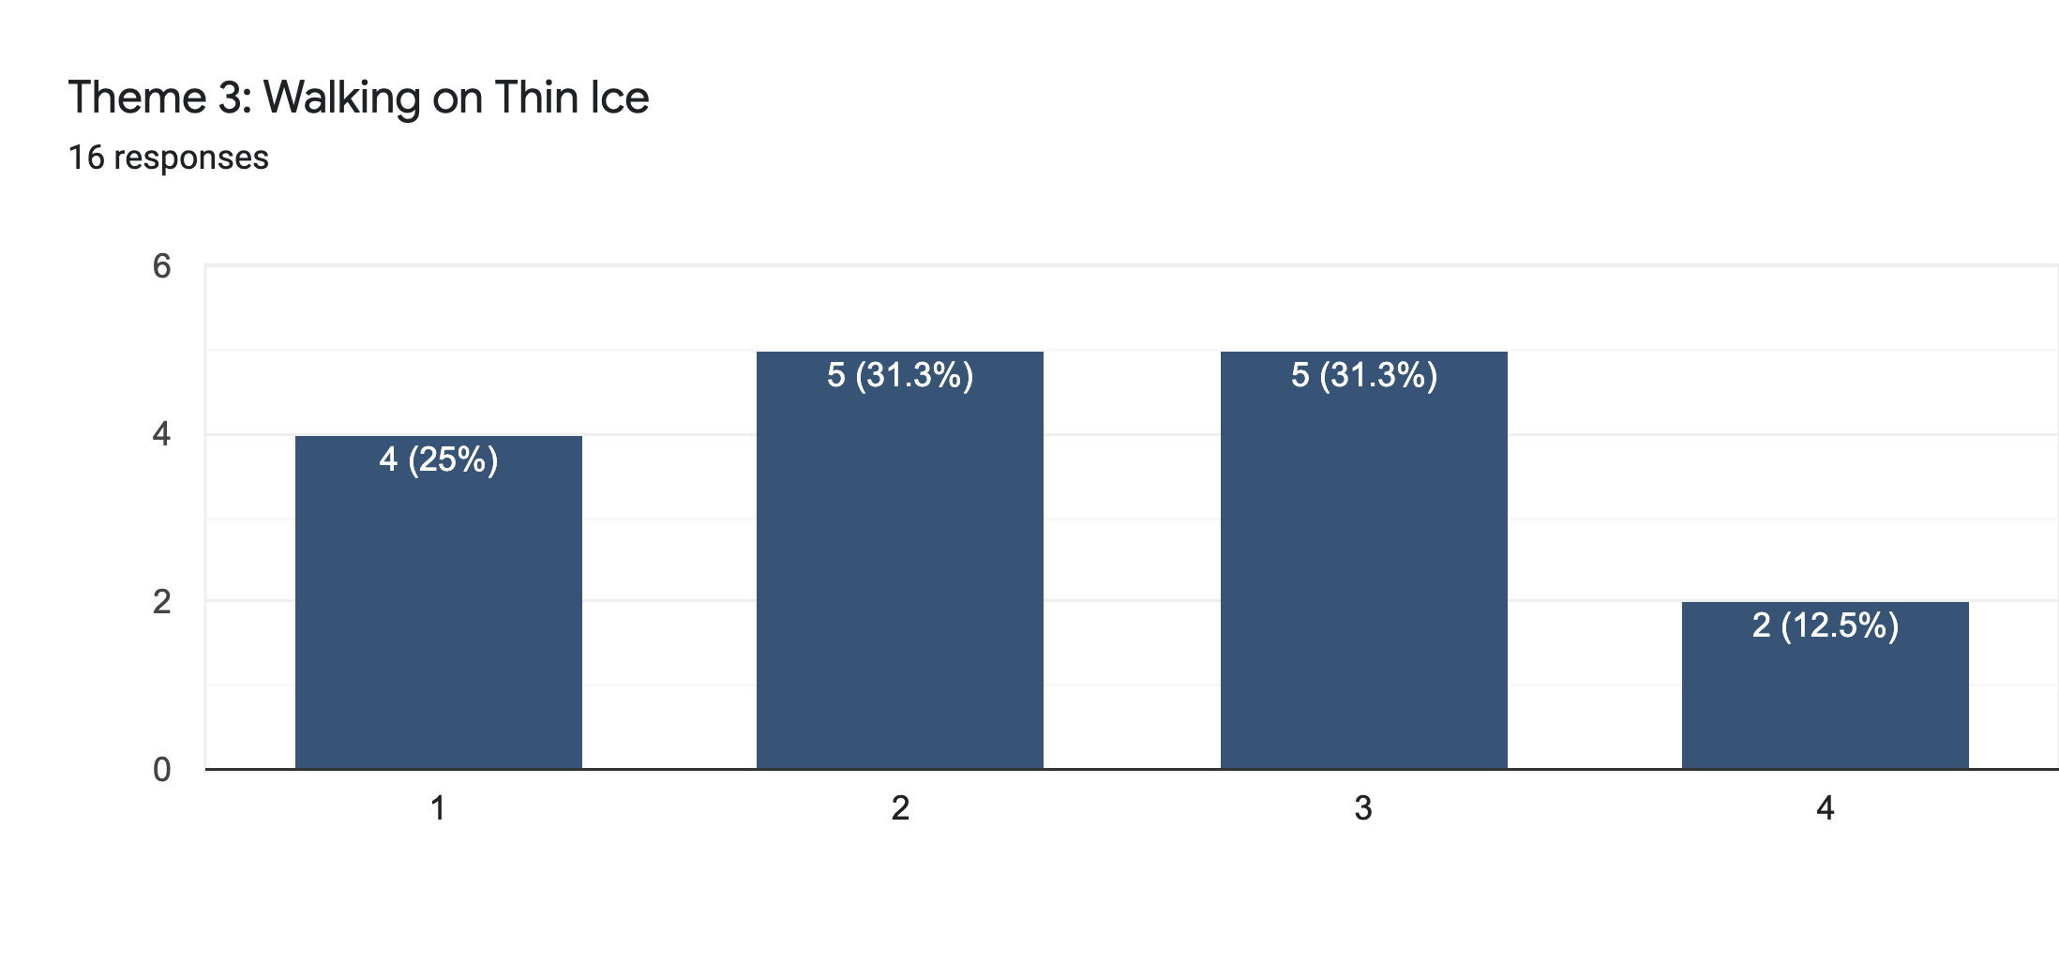

Top choice:

* Sends message clearly
* Like the content
* The kind of poster you would read if you are in a hurry and on the go. Content used is short and gets the message across
* 3: Few words and the use of images work really well to capture attention. Just like webtoon/comics, it should be fast enough for the audience to read and move on.

Bottom choice:

* It kinda looks like one of those government made a post talking about the issues and usually seen a lot so sometimes I would just assume.

Evaluation: The comic style of the theme attracts the audiences as it sends the message clearly and they are able to receive the content well. This shows great success in our design and readability portion of our theme. We can experiment with more styles to present our content and engage it with their audiences. The comic strip style seems to be a success.

Theme 4: The Pageant

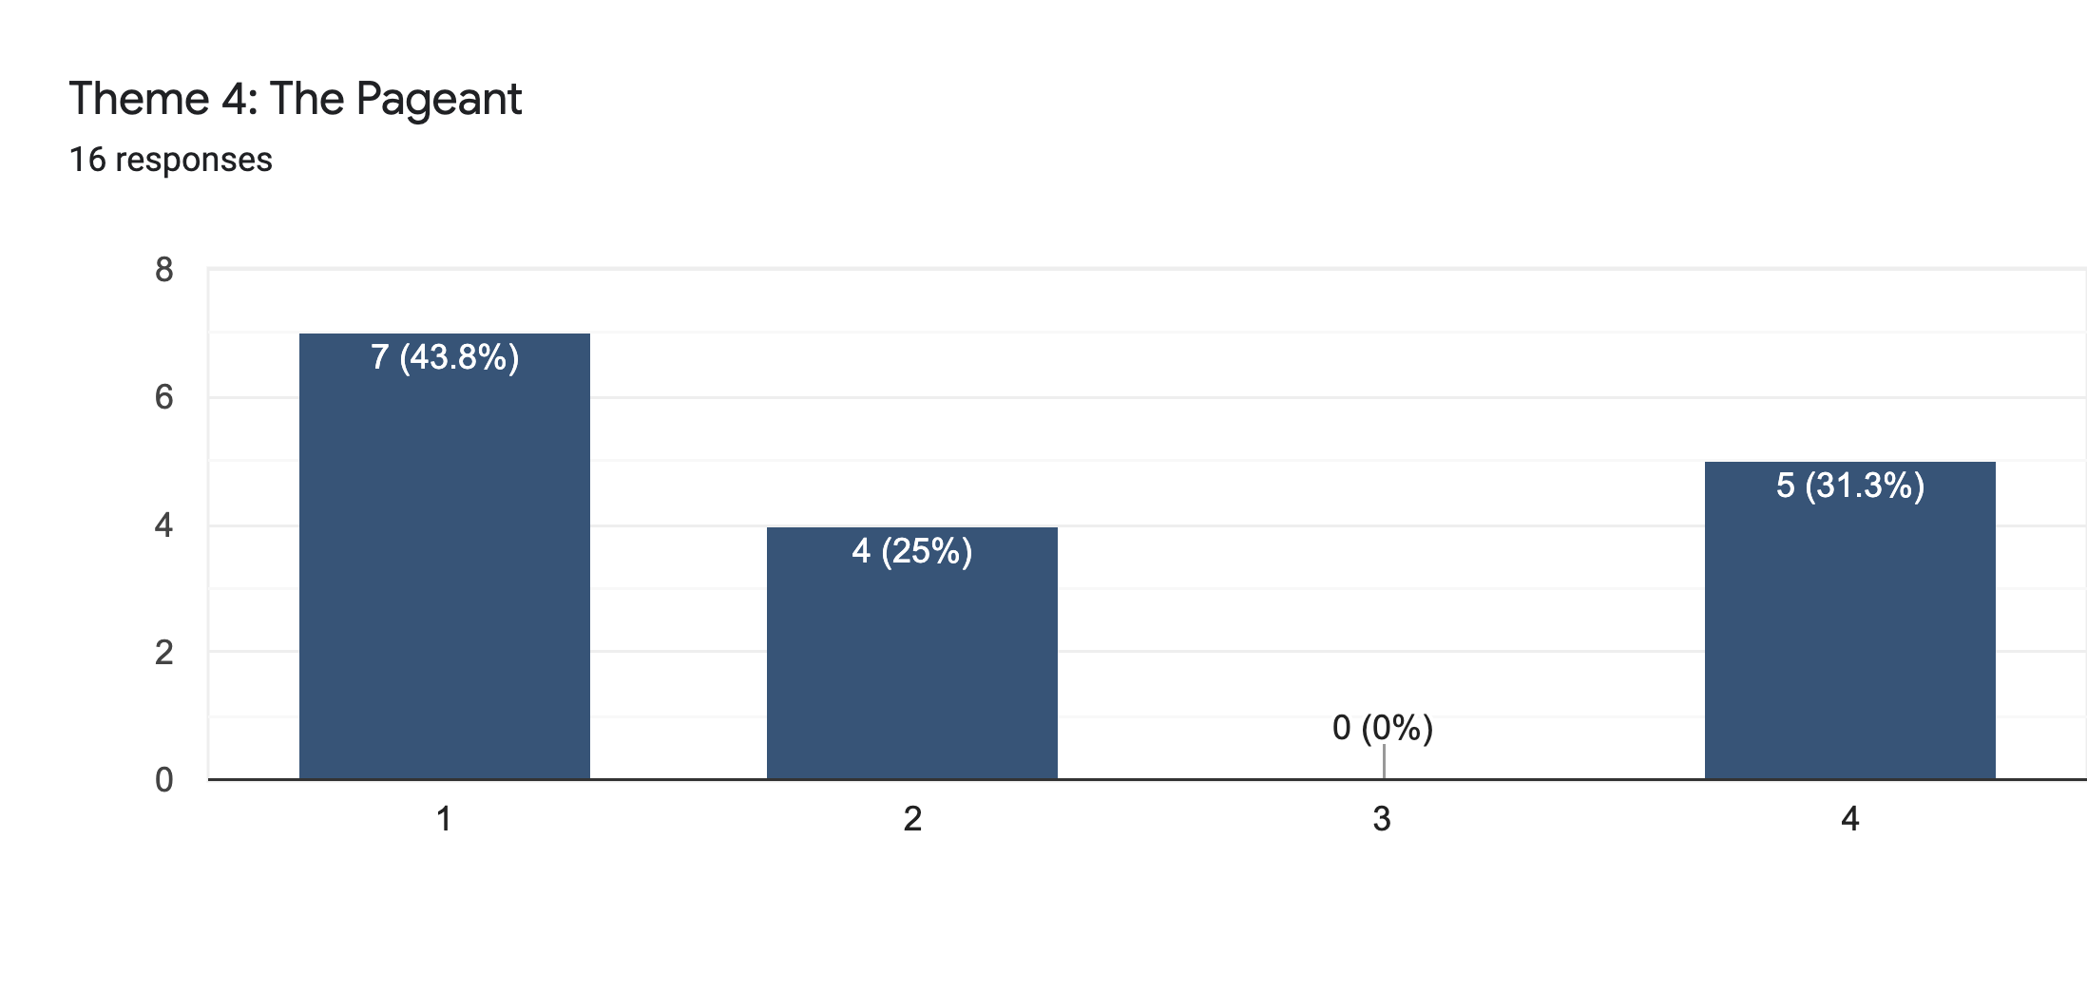

Top choice:

* Honestly I like the “model” format / idea
* the one i liked most, to me it is more eye catching
* It’s similar to magazine covers which generally would attract more attention than the rest on the list , although my 2nd choice was quite attention-grabbing as well.. The color is more out there compared to the other three which is pretty good, but maybe you could choose a different color that pops as well as the color used in the original theme. The pull quotes and the wrapping of paras with the image is pretty good too.. Maybe instead of just making it box-ish or square-ish , you could have a cut-out of the main character alone with no background , just solely the person , in the center of the page and the text to wrap around him/her , it would look more unique that way.. It really emphasises on the main character as well.
* Designs are better thn the first few themes.
* It's a post that I don't usually see on instagram and it usually intrigues me.
* Design is nice and easy to read. It also sticks to memory well. Quite eye-catching
* The most aesthetically pleasing as a believable design of a topic
* Of all 4 posts, the font used for the body text work the best. It has the best readability font. Maybe you could consider using more sans serif font like this instead of the font that is used for 1-3. But colour scheme doesn't really attract attention nor does it portray the message. There is low contrast between yellow, gold/brown and black.

Bottom choice:

* It's good when I first saw it, but compared to the rest of the themes, it's the least appealing kw
* Does not capture my attention
* It tells but not shows.
* Too lengthy and many words to read hence not catching my attention at first glance.

Evaluation: There is a mixed reaction to the Pageant theme. We have succeeded in capturing a lot of people’s attention, however we should pay more attention to colours and design that attracts the most audience in our target group so that it would be well received by different people. We can consider which readability and design styles are well-received by most people in our target group and use that as our base when presenting our content.

## Entertainment (1 Not entertaining/ 5 Extremely entertaining)

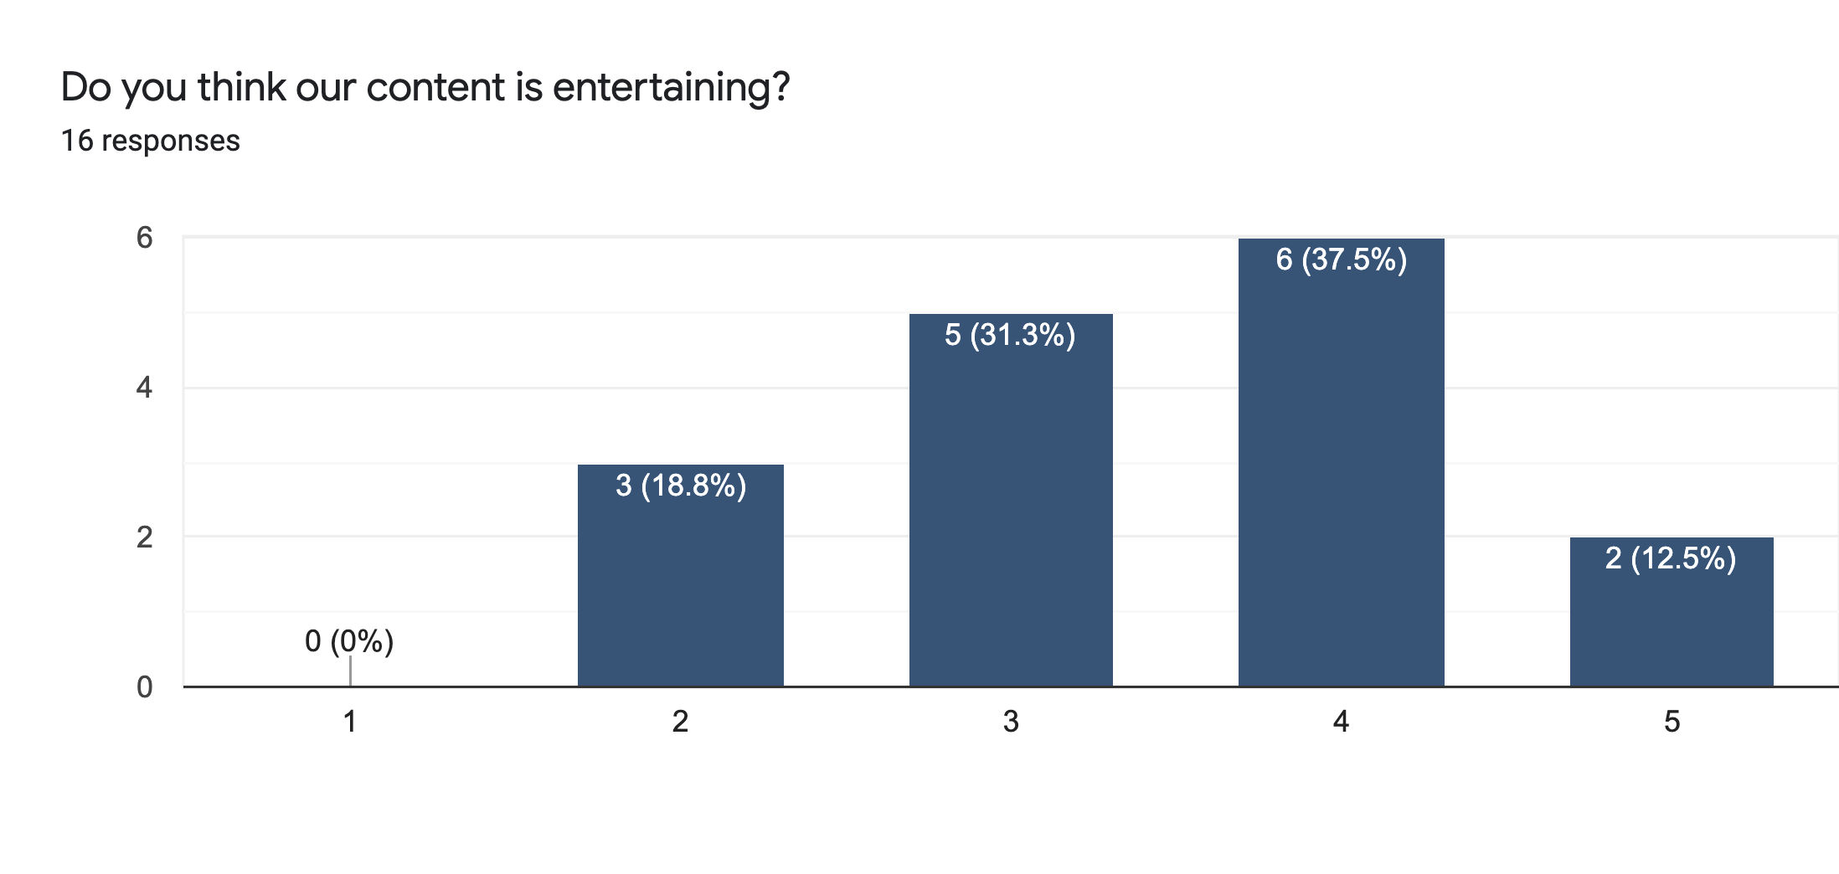

## Educational (1 Not educational / 5 Very educational)

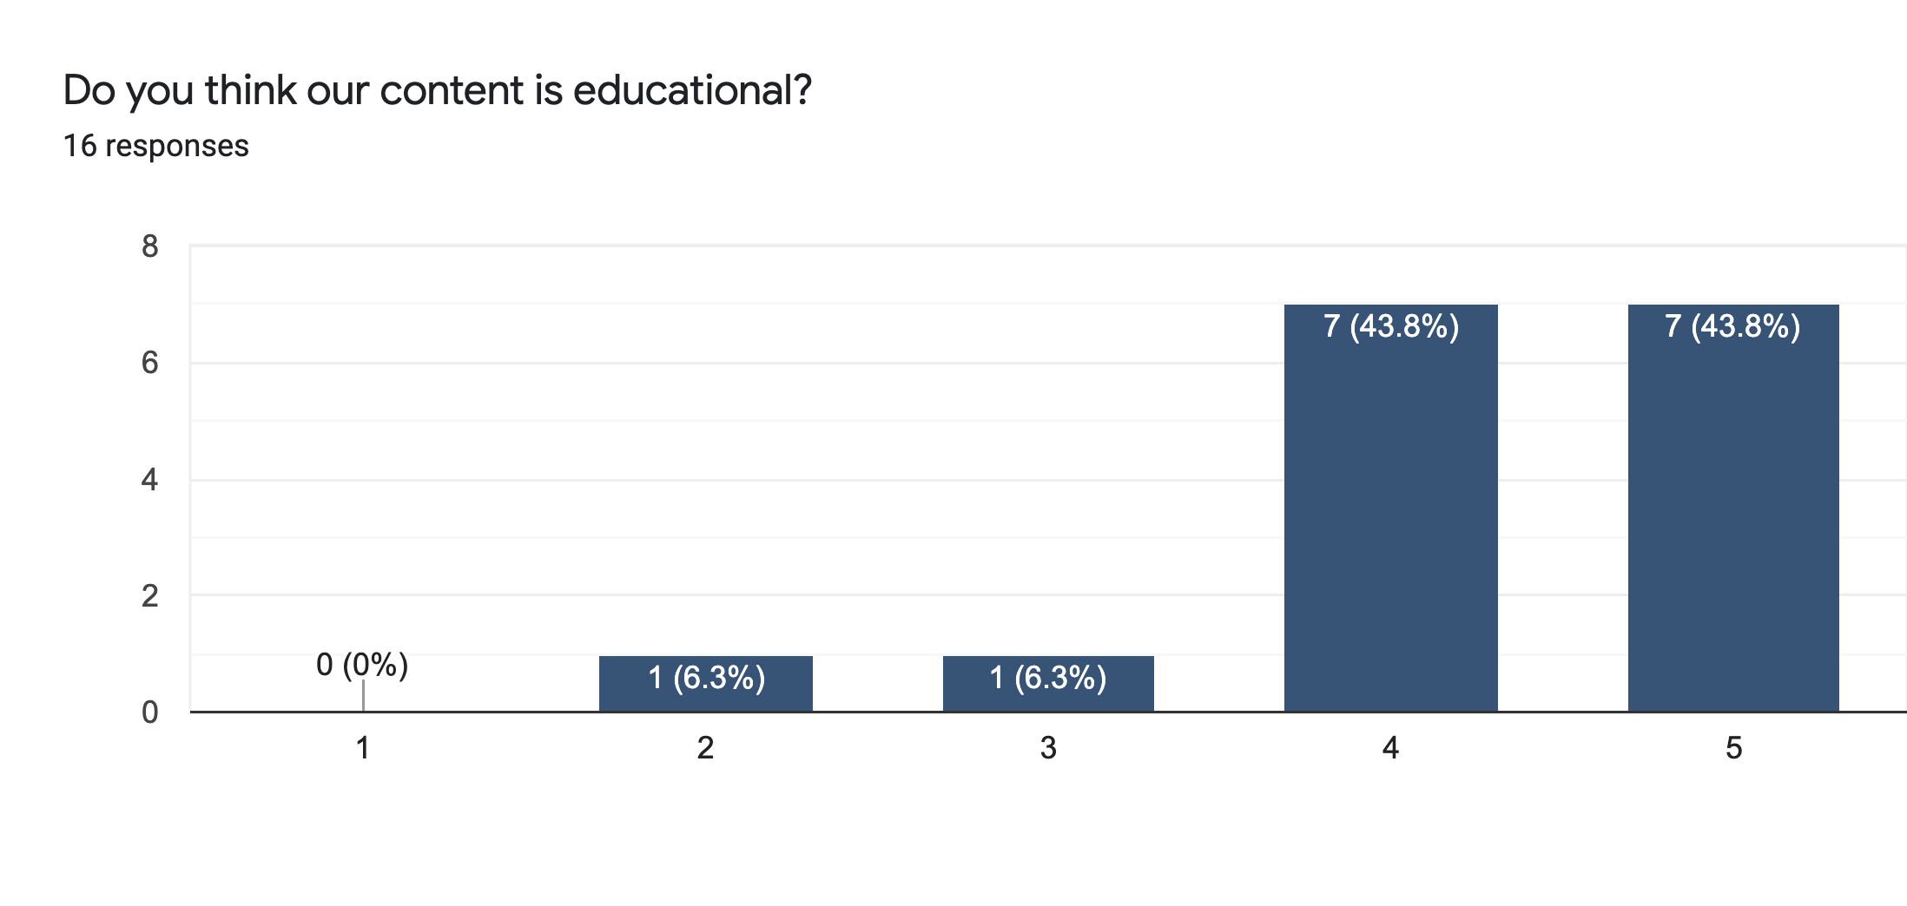

Evaluation: Our audience generally does not find our post very entertaining, but more educational. We can relook at the entertainment portion in terms of how we can improve in our design and themes of our content (Instagram posts).

## In which aspects are we doing well in our posts?

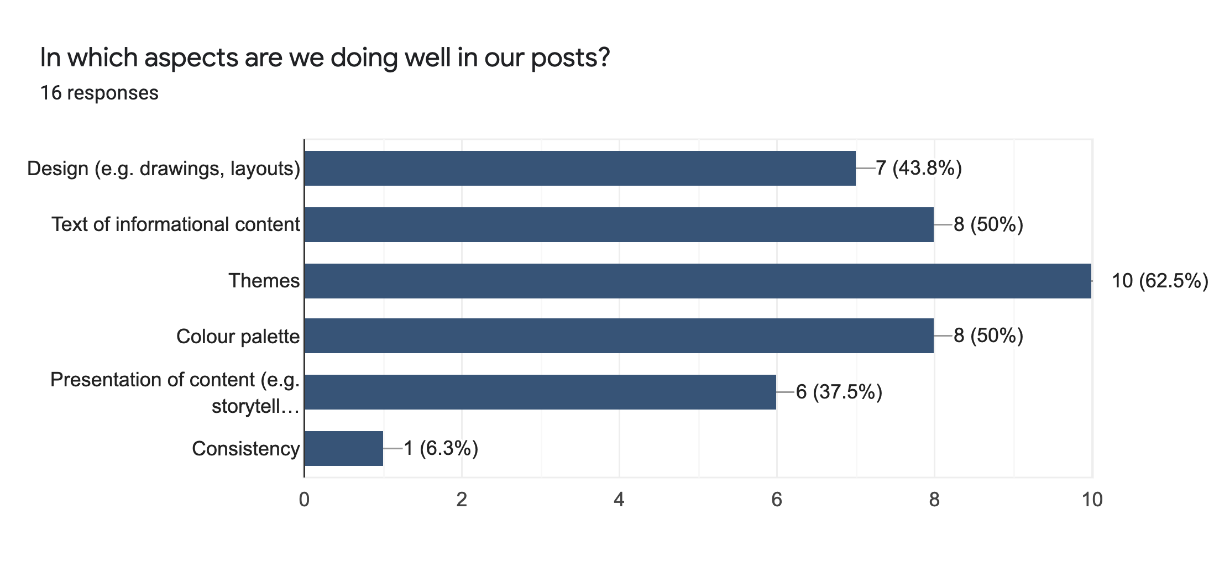

Evaluation: The audience has acknowledged our experimenting of themes and is attracted to the different styles in the way we present our content to them. They acknowledge the themes more, followed by our text of informational content and colour palette, followed by design and presentation.

## In which aspects should we improve on our posts?

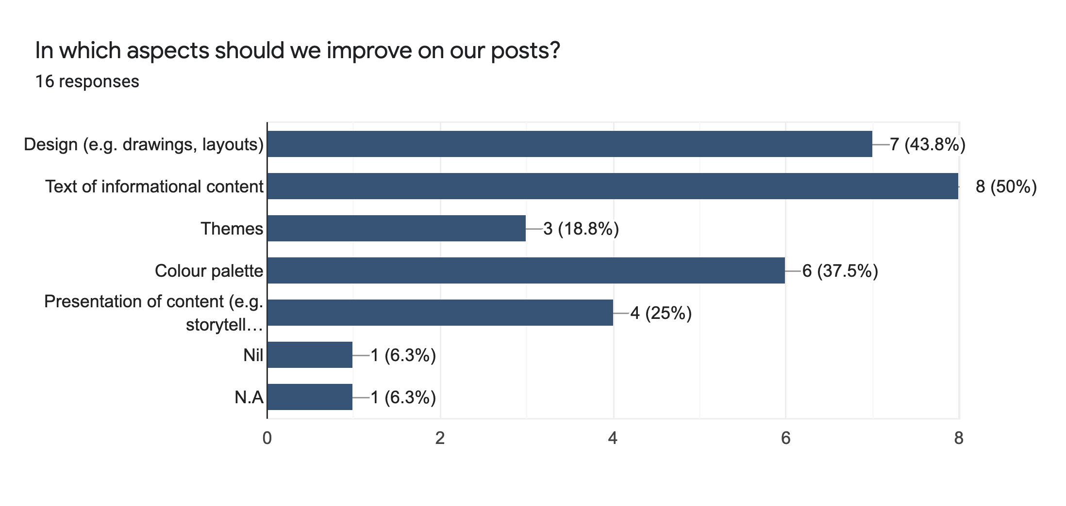

Evaluation: We should rethink of our basis in the readability and design styles that capture our audiences and use a basis when thinking of coming up with content. Readability of the informational text seems like a huge and noticeable issue in our Instagram posts, followed by design and colour palette.

## Is there anything more you would like to see from our Instagram Page?

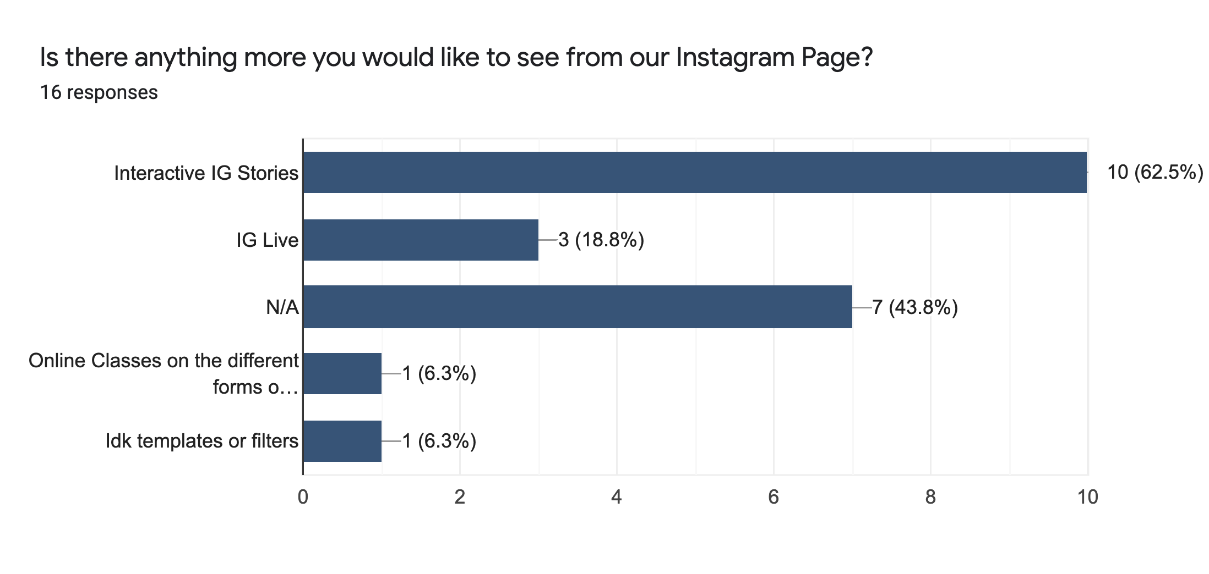

Evaluation: We can rethink more on how we can make our IG stories more interactive and the frequency of our stories. We can consider IG Live session, events and/or classes in the future.

## In a few words, please provide feedback on how we could improve our Instagram content.

The sentences highlighted in yellow are good considerations we can take into account for.

* Less words
* Relatable content
* You could do research on the timings and the days that has the highest frequency of consumers on the app itself because posting content during those timings or on those specific days would help in getting more reach. Singaporeans tend to browse through social media during their lunch breaks or after work so around noon or in the evening would be good timing to post content online. Hashtags do play a part in Instagram posts as well, so maybe to get your posts out there, maybe use relevant hashtags or those mainstream ones to get more exposure for your account and your content. Attention-grabbing colours would be useful too, and the designs as well. As for the content itself, I think it’s good enough so keep it up :)
* Consistent.
* Overall, it's very educational as it explains things i never heard of before
* Colour scheme
* Again, brand building can only come after there is a solid fan base.
* There are times where I do feel that the post are becoming one of those ministry of health kind of post.
* Keep posting and have more user interactive ig stories. Maybe guessing game based on the poster design and audience will need to guess the theme? Snippets of pictures associated to a theme of the upcoming show and audience can guess what is the title?
* More posts similar with Half an Apple's marketing + The Pagaent. Maybe add themed posts into highlights as well? (Dedicate a seperate IG story?)
* Have consistency in the design style to show your company brand. What is the image of your brand
* Contents are informative but they could be better presented. As for newcomers, I'm afraid they might not see your posts in relation to your production company. Even though those are the themes that TMGP talk about, there isn't much publicity about what you guys do except for the photos/videos of rehearsals on ig story.
* Cleaner design, less text in posts

Evaluation: We have to do more market research on our target audience and their reception to social media content. In the near future, we may need to conduct further surveys to the general public within our target group, connect with our competitors to know more about how they engage our target group, and dig into further research about marketing strategies.

Brand identity as a theatre company is important and we should focus on showcasing that more in our content, aside from promoting mental health. We should have consistency in a design style that is in line with our brand identity and that can attract more people in our target group. We can look into brand building and how to create a fan base.

# Collated recommendations

Race: We can aim to create more shows that attract more general audiences. Hence, we can propose to aim to diversify our audience demographics. For example, in the next production, we hope to attract more Chinese, Indian or Eurasian audiences. This is to acquire that we are spreading more to different communities in Singapore and more groups of youths can be reached, based on race.

Profession/Occupation: We can think about how we can reach out and appeal to the adults in the labour force (unemployed + employed) more to our shows.

We can look at the price of our tickets and our marketing plans towards targeting that occupation group.

Our main question: How can we promote more to the working class?

(ME)ntal has a positive reaction in terms of being educational and its audience satisfaction. However, it can be improved on immersion and entertainment. To improve immersion, we can relook at our front-of-house arrangements and set-up, as well as our storytelling approach. To improve on entertainment, we can focus on the training and development of our artists, our storytelling approach and our overall quality of performance we present to the audience.

Kampong Pokok has achieved its objectives of being a comedy as the audience was greatly immersed and entertained during the show. We can consider exploring creating more plays in the comedic genre and incorporating more comedic elements into our plays. We can research more on comedic plays and how we can create our own plays according to it. This can attract more audience within our target audience.

The audience found After 7 an emotional experience and found that aspect the most memorable. We consider relooking into more similar themes and bring it out in our plays. One major feedback is the publicity of our shows, which tells us to look back at our marketing plans for our future productions. In addition, we can look at different perspectives and stories of the same theme, by connecting with more people to share their experiences and stage it up as one of our future productions. However, some audience had a hard time immersing and being entertained with the play. This may be due to the fact that After 7 is centred around the Malay community and Islam. Audiences outside that circle may have felt disconnected with the content and intentions of the storyline, although they may learn more about the Malay culture and the religious practices of Islam. Community-centred plays are important in engaging the different communities in Singapore with one another. This helps to promote the growth of the identity of the central community by allowing the members in that community to come together and being immersed in their own cultural experience. We can look into more certain plays like this in future, but we can incorporate an educational factor so that audiences from other communities in Singapore can feel as entertained, educated and engaged.

Half an Apple received mixed reactions. However, one of the significances of the play is the educational portion which was one of the main objectives of the production. Although it was successful, it could have been done better by researching more in-depth and understanding different point-of-views of people suffering from such illnesses and stage it. The audience found the content and storytelling more surface level and was hard to immerse in. We have to relook in how we experiment with different storytelling approaches, whether it can engage and entertain audiences in our age range. We need to prioritise the information and context we bring to the table and how we present it to the public in our later works.

However, we will need to relook on how we can make it more educational, so that it’s educational content can be received better, or we can promote the awareness and information more of mental health through the front-of-house or the clarity of the storyline.

We need to relook at our marketing strategies and plans when promoting our productions to different groups of people in our target audience range. We can develop our stories more in the future in line with our company goals (entertain, educate and immerse) and that the story and how we present it can be received clearly and efficiently to our audience in line with our play’s objectives and themes.

We have a lot of people supporting our growth. However, we need to build an HR strategy in our business development plan, so that we can train and develop our talent and team members.

It can also be a review of our company image to them, as well as the quality of which we present our performances. For example, are our performance of high calibre quality or of low quality? We can rethink about the talent we bring in and training and development of them, the professionalism of the whole team, as well as how we can rectify the process of our productions so that it can increase the quality of our performances. For example, do we need more planning time? More roles delegation? More rehearsals time? More cross-training or exposure to different training and development activities conducted by external instructors? More research on the theme of the play?

We have to do more market research on our target audience and their reception to social media content. In the near future, we may need to conduct further surveys to the general public within our target group, connect with our competitors to know more about how they engage our target group, and dig into further research about marketing strategies.

We can rethink more on how we can make our IG stories more interactive and the frequency of our stories. We can consider IG Live session, events and/or classes in the future.

We should rethink of our basis in the readability and design styles that capture our audiences and use a basis when thinking of coming up with content. Readability of the informational text seems like a huge and noticeable issue in our Instagram posts, followed by design and colour palette.

The audience has acknowledged our experimenting of themes and is attracted to the different styles in the way we present our content to them. They acknowledge the themes more, followed by our text of informational content and colour palette, followed by design and presentation.

Brand identity as a theatre company is important and we should focus on showcasing that more in our content, aside from promoting mental health. We should have consistency in a design style that is in line with our brand identity and that can attract more people in our target group. We can look into brand building and how to create a fan base.